PyMovements-Supported Driver Risk Analysis

PyMovements-Supported Driver Risk Analysis

This project aims to develop an artificial intelligence-based analysis system capable of detecting two critical risks in drivers: drowsiness and distraction. The study will utilize the “Drowsiness” and “Distraction” subsets of the DMD. During the image processing stage, OpenCV and Dlib libraries are used to detect faces and eye points. These data are converted into time series format using PyMovements, and indicators such as PERCLOS, saccade speed, and fixation duration are calculated. Subsequently, a classification model will be created using the Random Forest algorithm.

Objective:
The main objective of this project is to develop a Driver Monitoring System (DMS) that detects two critical risk conditions, drowsiness and distraction, in real time and provides an immediate response through a warning mechanism, with the aim of providing an active solution to prevent traffic accidents.

Goals:
Within the scope of the project, a model capable of distinguishing drowsiness and distraction into three classes (Normal, Drowsiness, Distraction) will be developed. The developed system is expected to demonstrate high performance with sufficient accuracy and F1 score. An AI-based classification model will be created by combining PyMovements and OpenCV-based data; this model will be able to analyze the driver's cognitive state. The project aims to contribute to strengthening local software capacity and developing a sustainable R&D infrastructure by using open-source technologies.

Scientific Value:
Today, a significant portion of traffic accidents occur due to driver drowsiness and distraction, causing serious losses in terms of both safety and economics. Existing driver monitoring systems in the literature mostly focus on deep learning-based black box models, and methods based on explainable scientific metrics for decision-making are limited. This project aims to fill this gap in the literature by presenting the first scientific approach using the PyMovements library in the context of driver behavior analysis.
The main gaps identified in the literature are as follows:
- PyMovements is a modern tool that derives scientific quantities from eye movement time series; however, it has not been used in the literature for driver drowsiness or inattention analysis. This project, PERCLOS, obtains scientific quantities such as saccade speed and fixation duration through PyMovements, achieving the first academic integration of this library into the field of driver behavior analysis.
- Many studies in the literature require specialized eye-tracker hardware. This project proposes a low-cost, portable, and reproducible system that works with only a webcam and open-source libraries (OpenCV, MediaPipe, PyMovements, Scikit-learn).
- Current DMS studies are mostly based on deep learning-based black-box models, and the cause-and-effect relationship of decision processes cannot be explained. This project contributes an interpretable method to the literature by using a classification model.
- While many studies focus on a single risk type, this project presents a classification framework that evaluates three different cognitive/behavioral states of the driver within the same algorithm.

Technologies to be Used:
- Programming Language: Python
- OpenCV
- Dlib / MediaPipe
- PyMovements
- Scikit-learn
- Random Forest Algorithm.
- NumPy
- Pandas
- Matplotlib / Seaborn
- Webcam: Logitech BRIO 100 1080
- Laptop: Huawei MateBook D16

Method:
The “Drowsiness-related” and “Distraction-related” labeled subsets of the open-access Driver Monitoring Dataset (DMD) are used. The dataset contains face videos recorded under varying lighting conditions for different drivers. Python, OpenCV, Dlib, PyMovements, and Scikit-learn libraries are used for image processing and model training.

The goal is to extract attention and drowsiness states from visual data related to the driver's face and eye region. Critical points around the driver's face and eyes are detected using OpenCV and Dlib/MediaPipe on frames obtained from the image stream. The driver's head movements are obtained through these points. The Eye Aspect Ratio (EAR) value is calculated using the coordinates around the eyes; this ratio is evaluated as a drowsiness indicator representing the driver's eye openness level and blink frequency. The data obtained from the driver's eye movements is converted into scientific quantities using the PyMovements library. Three basic quantities are calculated from this data: PERCLOS is evaluated as a drowsiness indicator, saccade speed is evaluated as a measure of attention shift and cognitive load, and fixation duration is evaluated as an indicator of the driver's gaze stability.

The obtained eye and head movement data are processed to capture temporal trends. Using a sliding window method that represents specific time periods rather than instantaneous frames, summary statistics such as the mean and standard deviation are calculated for each window. Feature vectors composed of these statistics enable the model to learn behavioral changes over time.

In the final stage, the created feature vectors are classified using the Random Forest algorithm with a supervised learning approach. The Random Forest algorithm was chosen because it can process features of different scales and types without requiring normalization, is robust against noisy real-world data, and has explainable decision processes. The model has been trained to classify the driver's state into three classes: Normal, Drowsiness, and Distraction. The results obtained evaluate the driver's risk status in real time, and the system is designed to inform the driver via an auditory warning mechanism when a state is detected.

PyMovements

PYMOVEMENTS

What is PyMovements?
A Python package for analyzing eye-tracking data that follows best practices in software development,including rigorous testing and adherence to coding standards. The package provides functionality for key processes along the entire preprocessing pipeline.

Usage:
- Parsing of eye tracker datafiles
- Transforming positional data into velocity data
- Detecting gaze events like saccades and fixations
Saccade: Very fast, sudden, and jerky movements made by the eye from one focal point to another. If the speed is above a certain threshold, PyMovements marks this movement as a “Saccade.”
Fixations: The moment when the eye remains relatively stationary on an object or point and the brain collects visual information. PyMovements uses two main methods to detect fixations in raw data:
- Dispersion-based :If the eye has not moved outside a very narrow area (a circle of a few degrees) for a certain period of time, this is recorded as a “Fixation.”
- Velocity-based: When the eye movement speed falls below a certain threshold, the system detects this as a pause.
- Computing event properties like saccade amplitude
- Fixational dispersion and visualizing data and results with several types of plotting methods.

One of PyMovements' most distinctive features is its performance. It uses the Polars library, considered one of the fastest dataframe tools in Python. This allows it to process large datasets with millions of rows very quickly.
- Polars Library: Written in Rust, it is a high-performance dataframe library designed specifically for processing large datasets. It delivers much faster results compared to traditional tools (such as Pandas) because it can perform parallel processing by utilizing all cores of modern processors simultaneously. It manages resources efficiently by utilizing the memory-efficient Apache Arrow structure and a “lazy evaluation” system that optimizes queries before execution.
It features an interface for automatically downloading and processing popular academic datasets such as PyMovements, GazeBase, and JuDo1000.
Heatmaps: Show areas where the user focused.
Trace Plots: Visualize the eye's movement path over time.

Other Libraries
1-PyGaze
An open-source toolkit for eye tracking in Python. This is the homepage for PyGaze, an open-source toolkit for eye tracking in Python. It also includes related projects such as the PyGaze Analyzer and a webcam eye tracking device.
Advantages:
PyGaze's greatest strength is that it works with almost all eye tracking devices on the market (EyeLink, Tobii, SMI, Gazepoint, etc.).
If you don't have a physical eye tracking device, it allows you to test your experiment by using your mouse as an eye tracker.
Disadvantages:
PyGaze uses standard Python lists or Pandas during the data processing stage. Therefore, it is very slow when analyzing very large data sets.
PyGaze's main job is to “record” the data. Once the recording is complete, the tools it offers for cleaning, filtering, and complex event detection (saccade/fixation detection) are not modern or in-depth.

2-GazeParser
GazeParser was developed for low-cost eye tracking, gaze data recording, and analysis. It captures images from a camera to record eye position and subsequently performs calibration, synchronization of stimulus presentation along with recording and analysis of eye movements.
Advantages:
It can work with a standard webcam or low-cost USB cameras.
In tests, it offers a spatial error margin between 0.7° and 1.2°, which is an acceptable level for many general psychological and cognitive studies.
It can match the moment the stimulus is displayed on the screen with the moment the eye data is recorded with millisecond accuracy (error < 1ms).
Disadvantages:
Standard webcams have a low frame rate (FPS), so they may struggle to capture very fast eye movements (such as rapid jumps).
It usually requires the participant to keep their head still (chin rest/forehead rest). It does not offer advanced algorithms that allow the head to move freely.

3-PyTrack-NTU
PyTrack-NTU is a package that allows researchers to clean, analyze, and visualize raw data obtained from eye tracking devices.
Advantages:
It offers standard analysis tools such as fixation, saccade detection, heatmaps, and scanpath visualizations in a single package.
Disadvantages:
PyTrack-NTU uses Pandas for data frames. Pandas is slower than Polars.
PyTrack-NTU is more focused on visualization and basic analysis.

Why PyMovements?
PyMovements is a library that transforms raw data obtained from various sources into meaningful results by processing it through a scientific analysis pipeline, rather than performing data collection itself. Its hardware-independent structure offers high flexibility in processing coordinate data from various sources such as MediaPipe or OpenCV. Optimized for projects requiring extremely fast data processing, PyMovements efficiently performs complex sliding window operations on time series data. This ensures real-time tracking systems operate smoothly and reliably without any performance bottlenecks.

Dataset
DATASET

1) Driver Monitoring Dataset
The Driver Monitoring Dataset (DMD) is a video-based dataset consisting of in-vehicle camera footage, created to analyze the cognitive and behavioral states exhibited by drivers while operating a vehicle.

Data Content
The Driver Monitoring Dataset (DMD) consists of video recordings captured in RGB format, focusing on the driver's face. The dataset contains realistic driving scenarios with drivers behind the wheel and is designed to reflect in-vehicle conditions. Since each video is recorded with a camera positioned to center the driver's face, it is possible to detect and analyze eye, face, and head movements with high accuracy. In addition, the videos are recorded under different lighting conditions and include variability in factors such as camera angle and face position.

Subsets and Label Structure
The Driver Monitoring Dataset (DMD) consists of two main subsets used in the study.

Drowsiness-related subset:
This subset includes situations where the driver shows signs of drowsiness. This subset includes behaviors indicative of drowsiness, such as prolonged eye closures, increased blink rate, and fatigue-related facial expressions.

Distraction-related subset:
covers situations where the driver's attention is diverted from the road. This subset includes head movements to the right, left, or down, the driver looking away from the road, and head movements associated with loss of attention.
The labels in the dataset are defined to represent the driver's risk status for each video or video segment, enabling the differentiation between drowsiness and distraction states.

Environmental and Individual Diversity
DMD reflects individual differences such as facial structure, eyewear use, and driving habits, as it includes data from different drivers. Additionally, the dataset includes different lighting conditions, camera angles, and face positions. This diversity supports the developed model's ability to adapt to different driving scenarios and increases its generalizability.

Limitations
Possible limitations include the limited detail of the labels in the dataset and the uneven distribution of sample numbers in some risk classes.

2- NTHU Driver Drowsiness Detection Dataset
The NTHU Driver Drowsiness Detection Dataset is a video-based dataset created to analyze drivers' drowsiness and fatigue levels, obtained from in-vehicle camera footage. The dataset focuses specifically on detecting physiological signs of drowsiness that occur while driving. The recordings were obtained using a camera positioned to directly view the driver's face, allowing for detailed analysis of eye and mouth movements.

Data Structure and Content
The NTHU dataset consists of video recordings captured in RGB format. The videos are suitable for frame-by-frame analysis and allow for temporal examination. The recordings were mostly obtained under controlled or semi-controlled driving scenarios and include situations where drivers consciously exhibited signs of drowsiness. This structure provides a suitable environment for developing and evaluating drowsiness detection algorithms.

Subsets and Labeling Structure
The dataset contains different scenarios labeled according to the driver's physiological state. These scenarios include situations where the eyes are open, prolonged eye closures, and yawning, which are behaviors specific to drowsiness. Each video or video segment is labeled to represent the driver's drowsiness state, and labels for inattention are not included in the dataset.

Environmental and Individual Diversity
The NTHU dataset offers a certain degree of diversity in terms of facial structure and driver habits, as it contains recordings from different drivers. However, since most of the recordings were obtained in controlled environments, environmental diversity is limited compared to real driving conditions. This makes the dataset particularly suitable for studies focused on drowsiness detection.

Limitations
The dataset does not cover cognitive states such as inattention and reflects environmental variables in real driving conditions to a limited extent. These limitations necessitate the use of the dataset primarily for drowsiness detection and comparative analysis in studies.

3-YawDD Dataset
The YawDD Dataset is a collection of in-vehicle facial videos created to analyze drivers' fatigue and drowsiness symptoms from a behavioral perspective. The dataset focuses specifically on detecting behaviors characteristic of drowsiness, such as yawning and eye closure. The camera placement is positioned to clearly capture the driver's facial region.

Data Structure and Content
The YawDD dataset consists of video recordings captured in RGB format. The videos are suitable for frame-by-frame analysis, allowing for detailed examination of the mouth and eye regions. The recordings include scenarios where drivers exhibit signs of fatigue in natural or semi-controlled settings.

Subsets and Labeling Structure
The videos in the dataset are labeled according to behaviors indicative of drowsiness, such as yawning and eye closure. The labeling structure is designed to distinguish behavioral signs of drowsiness in drivers. The dataset does not include labels for inattention and is primarily used for drowsiness analysis.

Environmental and Individual Diversity
YawDD offers a certain degree of individual diversity as it includes recordings from different drivers. However, diversity in terms of environmental conditions and driving scenarios is limited. Therefore, the dataset is considered a supporting resource for analyzing behavioral drowsiness indicators.

Limitations
The dataset focuses solely on drowsiness indicators and does not contain information on inattentiveness. Furthermore, the limited temporal and environmental diversity restricts the use of the dataset alone for real-time driver monitoring systems.

4-The Driver Distraction Dataset (State Farm)
The Driver Distraction Dataset (State Farm) is an image-based dataset created from in-vehicle camera footage to classify driver distraction behaviors. The dataset focuses on analyzing situations where the driver's attention is distracted due to non-driving activities.

Data Structure and Content
The State Farm dataset consists of individual images recorded in RGB format. The dataset is not video-based, allowing analysis to be performed on frame-based images. The images were captured to cover the driver's upper body and face, providing a suitable structure for behavior classification.

Subsets and Labeling Structure
The dataset is labeled under different classes based on the driver's attention state. These classes include behaviors representing distraction, such as looking at the road, looking at the phone, and looking away from the road. Labeling is behavior-based and does not include drowsiness states.

Environmental and Individual Diversity
The State Farm dataset offers individual diversity thanks to images obtained from different drivers and different in-vehicle conditions. However, because the dataset is image-based, it does not allow for temporal behavior analysis.

Limitations
The dataset does not contain video or time series information, making it unsuitable for calculating temporal metrics such as PERCLOS or saccade rate. Furthermore, its exclusion of drowsiness states requires the dataset to be used solely for inattention analysis.

Why do we use the DMD dataset?
This study selected the Driver Monitoring Dataset because DMD presents two critical driver risks -drowsiness and inattention- within the same dataset. Its video-based structure allows for temporal analysis and enables the calculation of time-dependent metrics such as saccade speed using PERCLOS. Furthermore, its reflection of real driving conditions and compatibility with the image processing and eye movement analysis libraries used make DMD the most suitable dataset for this study.

Technical Issue Faced
Some videos in the DMD dataset, particularly IR (infrared)-based recordings, cannot be opened by standard media players (e.g., Windows Media Player). This is not because the videos are corrupted, but because the dataset was prepared for research purposes using special codecs and encoding settings. A technical issue related to codec compatibility and video accessibility was identified before starting work on the dataset.

Solution
To better understand the source of the problem and identify possible solutions, different codec packages and video conversion tools were researched.

K-Lite Codec Pack
K-Lite Codec Pack is a software package that provides the codec and decoder components necessary for correctly opening different video and audio formats on a computer. Since Windows' own media players only support a limited number of formats, videos prepared for research purposes or with special encoding settings may not be opened by these players.

Usage
A codec is a software component that determines how a video or audio file is compressed and how it is decompressed; in other words, it enables digital media to be recorded and read again. A video file cannot be opened without the correct codec because the system does not know how to decompress the data. K-Lite Codec Pack eliminates this problem by adding the necessary codec and decoder components to the Windows operating system to support different video and audio formats. This ensures that videos with special encoding settings or prepared for research purposes can be correctly read and processed by standard media players and analysis tools.

HandBrake
HandBrake is open-source video transcoding software used to convert video files to different formats and codec structures. It ensures that videos that cannot be opened or are incompatible with analysis tools due to different codec settings are converted to more common and standard formats while preserving content integrity.

Usage
It re-encodes videos that cannot be opened or are incompatible with analysis tools without interfering with their content, reproducing them in standard formats. This allows the resolution, frame rate, and encoding structure of the videos to be adjusted, ensuring they can be read seamlessly by image processing libraries such as OpenCV.

FFmpeg
FFmpeg is an open-source, cross-platform multimedia processing tool used for handling audio and video data. It is command-line based and can perform operations such as reading, converting, re-encoding, compressing, and analyzing video/audio files.

Usage
FFmpeg is an open-source multimedia processing tool used for converting video and audio files to different formats, re-encoding them, and analyzing their technical specifications. It enables the automatic and reliable execution of pre-processing steps such as frame rate, pixel format, and codec standardization in large-scale video datasets.

Video Standardization Processes Performed with FFmpeg
Some videos are not supported by standard media players due to the encoding profile used. Therefore, even though the files are not corrupted, they cannot be opened directly on a computer.
Using FFmpeg, the encoding structure of the videos was analyzed and converted to a standard format. In this context, the videos were re-encoded with the H.264 (libx264) codec, the pixel format was set to yuv420p (4:2:0), and the frame rate was fixed at 30 FPS to ensure consistency in the analysis. Since audio data was not used in the analysis process, the audio channel was removed. The converted videos were recreated with the _std.mp4 extension within the same folder structure, preserving the original files, and all processes were automatically applied, including subfolders. As a result of this process, the dataset has been made fully compatible with both standard media players and image processing tools such as OpenCV and PyMovements.
The command used to convert all MP4s:
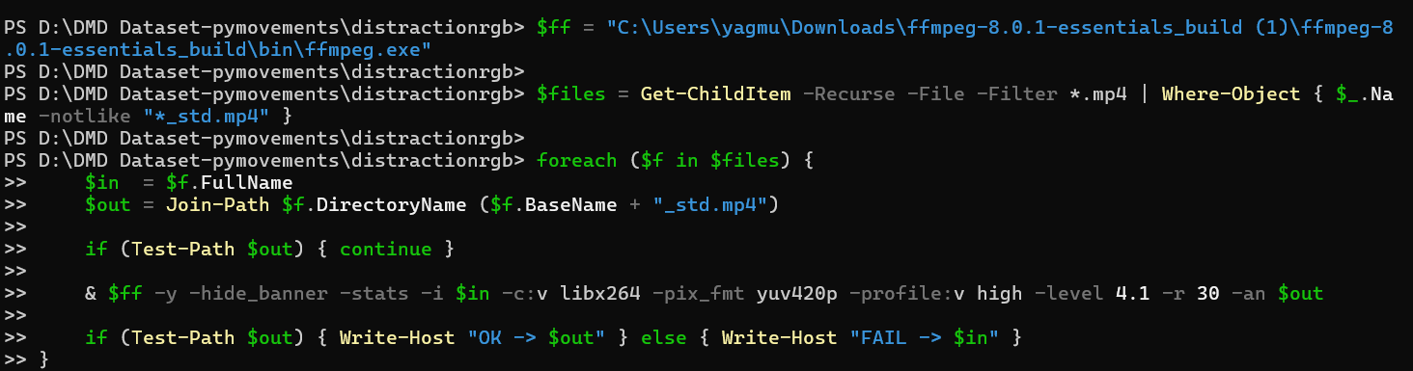

Literature review

LITERATURE REVIEW

1-Driver Drowsiness Detection System-Meriem boumehed , Belal Al Shaqaqi , Abdullah Salem Baquhaizel and Mohamed El Amine Ouis

Purpose:
In this paper, a module for Advanced Driver Assistance System (ADAS) is presented to reduce the number of accidents due to drivers fatigue and hence increase the transportation safety; this system deals with automatic driver drowsiness detection based on visual information and Artificial Intelligence.

Dataset:
several drivers.

Model Structure:
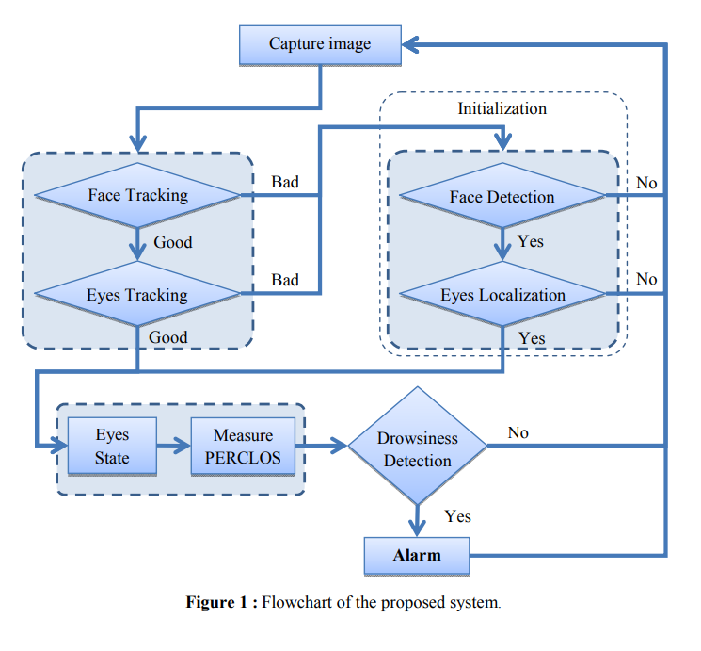
Face Detection:
Instead of the traditional pixel-based method for face detection, symmetry is calculated between the Z1 and Z2 windows according to specific threshold values. After determining the vertical line with the highest symmetry value, this area is scanned with a mask the size of the face to identify the actual face area with maximum energy.
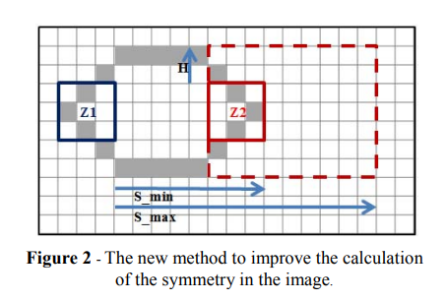

For each Z1 window, we scan the Z2 window within the area defined by the S_min, S_max, and H parameters. If the total number of white pixels falls between two threshold values, S1 (maximum) and S2 (minimum), we enhance the symmetry signal between these two windows. We then extract the vertical image contours corresponding to the maximum index of the obtained symmetry signal. Next, we take a rectangle with an estimated face size and scan the ROI by searching for the region containing the maximum energy corresponding to the face.
Eyes Localization:
Eye detection is performed by scanning for vertical symmetry in a specific region of the face (eROI). Symmetry is then calculated again on the right and left sides of this defined region to determine the eye centers.
Tracking:
The tracking is done by Template Matching using the SAD Algorithm.
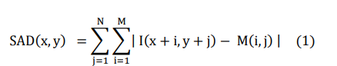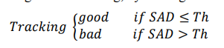
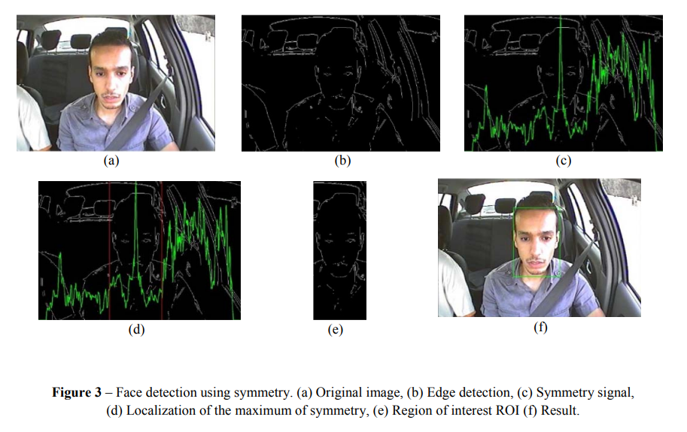

Eyes States:
Determining the eye state involves dividing it into two states: eye open or eye closed. To detect the iris, we use the Hough Transform (HTC) on the eye image. We apply the HTC to the eye's edge image and ultimately obtain the circle with the highest value in Hough's accumulator for all radii. Then, we measure the intersection level between the edge image and the full circle obtained by HTC using the logical ‘AND’ operation, and we measure this as “S”.
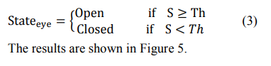

Driver State:
We determine the driver's condition by measuring PERCLOS. If the driver closes their eyes several times in at least 5 consecutive frames over a period of up to 5 seconds, they are considered drowsy.

Performance:
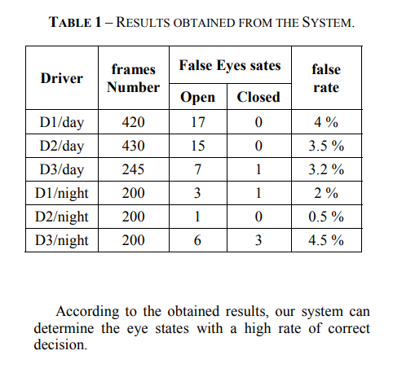

Input:
Driver's eye movements.

Output:
driver drowsy or not.

Strengths:
It can determine the driver's condition under real daytime and nighttime conditions.

Limitations:
It does not operate in real time.

Contributions:
The project's fundamental contribution to the literature is the introduction of a new symmetry algorithm based on the Z1-Z2 window for face detection. Supported by SAD and Hough transform, this system provides stable, computationally efficient, and accurate PERCLOS measurement in both day and night conditions.

Difference:
Window-Based Symmetry
Tracking with SAD Algorithm
Hough Circle Transform (HCT) and Logical Analysis

2-Driver Inattention Monitoring System for Intelligent Vehicles: A Review-Yanchao Dong, Zhencheng Hu, Member, IEEE, Keiichi Uchimura, and Nobuki Murayama
Purpose:
To classify existing technologies for monitoring driver inattention fatigue and distraction, compare the measurement methods and algorithms used in this field, and identify the most feasible solutions for real-time driving safety.

Datasets:
The article focuses on three types of data sources within the scope of the analyzed studies:
Simulator Data:
EEG, steering, and lane tracking data collected in controlled laboratory environments.
Field Operational Tests:
Data collected with real vehicles on specific routes (e.g., SAVE-IT program data).
Naturalistic Driving Data:
Comprehensive datasets from drivers monitored for months in their daily lives.
Biological Signal Data:
EEG (brain waves), ECG (heart rhythm), EOG (eye movements), and sEMG (muscle activity) recordings.

Modeling Techniques and Algorithms
ANN:
One of the main advantages of ANNs is that they infer solutions from data with no prior knowledge of the patterns in the data, i.e., they empirically extract the patterns even if the equation between the inputs and outputs does not exist.

SVM:
The learning technique of the SVM method makes it suitable to measure the cognitive states of humans. SVMs can generate both linear and nonlinear models to look for a hyperplane in the transformed domain that separates the data with minimum error and maximum gain.

Fuzzy Logic/FIS:
The fuzzy inference system is famous for its well-known linguistic concept modeling ability. The fuzzy rule expression is close to an expert natural language. A fuzzy system then manages the uncertain knowledge and infers high-level behaviors from the observed data.

BN:
The hierarchical structure of BNs can systematically present information from different sources and at different levels of abstraction and can also capture probabilistic relationships BNs can handle situations with missing data.

HMM:
The foundation of HMM is a stochastic Markov process that consists of a number of states with corresponding transitions used to predict route maneuvers.

AdaBoost:
In AdaBoost, learning involves the creation of different classifiers while successively changing the weighting of the learning data. A weighted majority decision is then made for these multiple classifiers to obtain the final classifier function recognition time of AdaBoost was approximately 1/26 of SVM.

PCA ve LDA:
Rather than using principal component analysis or linear discriminate analysis to reduce the dimension of the features, they chose the sequential floating forward selection (SFFS) algorithm to select the most promising features to construct a classifier.

Strengths:
Biological Measurements:
- High accuracy and direct brain/body data.
Physical Measurements:
Non-contact (using a camera), does not disturb the driver.
Driving Performance:
Low sensor cost, vehicle data readily available.
Hybrid Methods:
Most reliable results, low false alarm rate.

Limitations:
Biological Measurements:
Invasive (requires electrodes), impractical, sensitive to noise.
Physical Measurements:
Affected by light changes, may be obstructed by glasses/sunscreen.
Driving Performance:
Varies depending on driver experience, may detect fatigue too late.
Hybrid Methods:
High computational cost, requires complex system design.

Performance
EEG-based fatigue detection: 87%–90% accuracy.
Fusion of physical cues (Eye + Head + Face): Detection rates up to 98%.
Hybrid ANN (Steering + Eye): 88% accuracy, 9% false alarm rate.
Attention distraction detection with AdaBoost: Faster than SVM (by a factor of 1/26) and similar accuracy results.

Contributions and Key Differences
The article's greatest contribution to the literature is clarifying the characteristic differences between the methods:
Visual distraction (not looking at the road) impairs steering control and lane keeping, while cognitive distraction (thinking about something else) affects longitudinal control (braking time, following distance) more. It even highlights a paradoxical finding: when cognitive load increases, drivers remain more stable within the lane (narrow tunnel vision). The article demonstrates that a single measurement (only eyes or only steering) can never be perfect; physical measurements (cause) must be combined with driving performance data (effect).

3-An Intelligent Driver Monitoring System -P. Supraja, P. Revati, K.Sushmitha Ram, Jyotsna C.

Purpose:
This project presents a CNN based model that gives the feedback of the driver to the owner of the car by sending a text message. The model has been trained with different classes of distraction that has been observed among the drivers. Proposed model consists of vgg16 which is fine tuned pre-trained model to perform the classification with the help of an Adam Optimizer. Twillio SMS API is used for sending SMS to the owner of the vehicle or corresponding authority.

Datasets:
State Farm Distracted Driver Detection
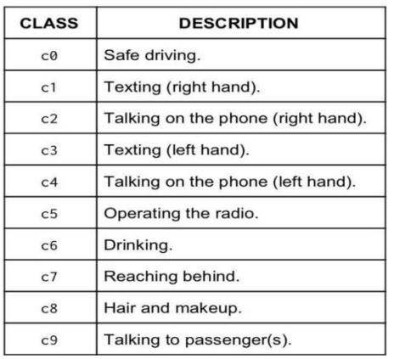

Model Structure:
Preprocessing:
Resizing of images to a target size of 224x224.
Zooming:To enlarge a picture in a sense that the details in the image become more visible and clear.
Shearing: Shearing changes the shape and size of the objects in both X and Y direction.

System Model:
The driver's image is given as input to the VGG16 model which performs different convolutions and max pooling operation on images.This model basically helps in determining whether the driver is following safe driving protocol or not.
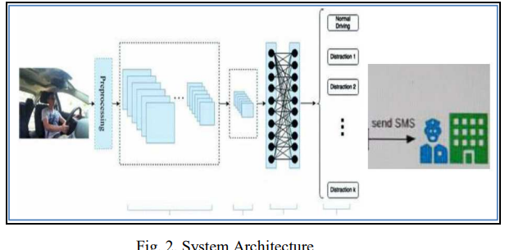

The automatic labelling of the data will be done by ImageDataGenerator so that the data can be easily passed to the neural network. ReLU is used as the activation function which restricts the negative values to pass to the next layer. ReLU activation is used for both the dense layer of 4096 units so that it stops passing non-positive(negative) values through the network.

VGG16 Architecture:
This model achieves 92.7% accuracy when trained on a dataset (ImageNet) with 14 million images and about 1000 classes. In VGG16, as the name suggests this neural network has 16 layers. The types of layers present are convolutional, max pooling, fully connected and softmax.
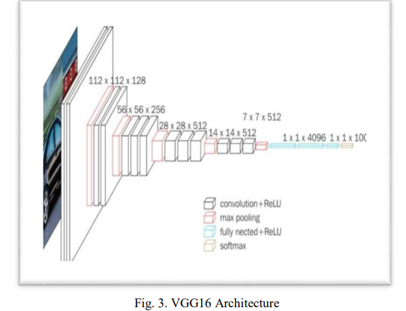

Convolutional Layers :
In convolutional neural networks the kernel is a matrix used to extract the features from the input image by performing the dot product with the subregion of the input. Stride is by how many pixels the kernel is moving.
The main agenda of CNN is to convert the input image to a form which is simpler to work on. The ConvNet is used for extracting the high-level features such as lines, edges, contours etc. The ConvNets are extended to many layers instead of just restricting to one layer. The model adjusts itself to the specific features when additional layers are added. This helps in giving a deeper understanding of Neural Net.

Activation Functions:
Activations Functions are used to help the model learn complex patterns in the data, the activation function is at the end deciding what is to be fired to the next neuron. The activation used in convolution layers, max-pooling layers, is ReLU to avoid passing negative values to other layers. We use the softmax function in the last layer, It is used for problems with more than 2 classes.
The input image is converted into a convenient form for our Multi- Level Perceptron, then flattening is performed. Our model used twilio to alert the driver or the owner of the car about distraction detected by the driver.

Input:
The driver's image is given as input.

Output:
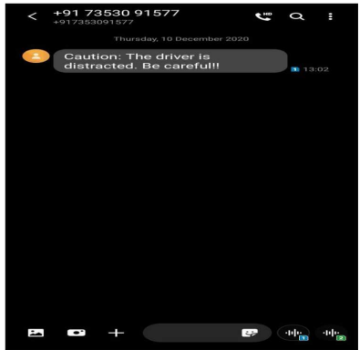

Performance:
This model achieved an accuracy of 93.75%.

Strengths:
Advantages of the VGG16 Architecture:
Instead of one ReLU activation unit found in standard models, VGG has three ReLU units, making the decision function more selective and specific. It minimizes the number of parameters in convolutional (CONV) layers, improving training time. It is much deeper than other deep learning models, allowing for the learning of more complex features.
It has the ability to send instant SMS alerts to the vehicle owner or authorities worldwide when inattention is detected.

Limitations:
We can develop an application which consists of a database having phone numbers of all the drivers and their respective authority. After fetching the respective driver’s number, we can send a caution message to the authority.
This model can be expanded and incorporated with various features so that eventually the driving system can handle all types of vehicles, under different driving conditions and conditions.
In ConvNet, a huge amount of samples is required to obtain a precise and generalizable model. However, there may not be an adequate number of images which are labeled to be used for learning specific and discriminative features from raw pixels.
Since the number of images are 22400, it results in overfitting.

Contributions:
Optimizing the VGG16 Architecture: The paper adapts the pre-trained VGG16 model to the driver tracking task by fine-tuning it using techniques such as the Adam Optimizer and ImageDataGenerator.

Difference:
VGG has 3 ReLU activation function units instead of 1 so the decision function is more selective and particular.
It highlights that models such as Inception V3 may carry the risk of overfitting when used with the ImageNet database; however, by combining data augmentation techniques with the Adam Optimizer and ImageDataGenerator in their own models, they achieved a high accuracy of 93.75%.

4-Affordable Visual ]Driver Monitoring System for Fatigue and Monotony-Thomas Brandt, Andry Rakotonirainy

Purpose:
In this study, we present a vision-based driver monitoring system to track the driver's head movements and eye blink patterns. Based on these measured features, the system can detect signs of fatigue and monotony.

Datasets:
Large amount of pictures showing faces and an even bigger amount of pictures showing no faces is required.
The used video streams were newscasts and film trailers from the internet.

Model Structure:
The face detection is integrated in the first process, the second one includes the eye extraction from the face area and some image preparation to reduce the amount of data and to speed up the algorithm. In the last process we measure the eye activities or the lack of eye blinks.

Face Detection:
The “Boosted cascade of Haar-like features” method is used. The image is divided into small windows, and the intensity differences (Haar wavelets) in each window are analyzed. The system consists of a series of decision stages (24 stages). If a window is marked as “not a face,” it is immediately rejected; if it is marked as “could be a face,” it proceeds to the next, more detailed stage. This way, the processor does not waste time on unnecessary areas and works very quickly.
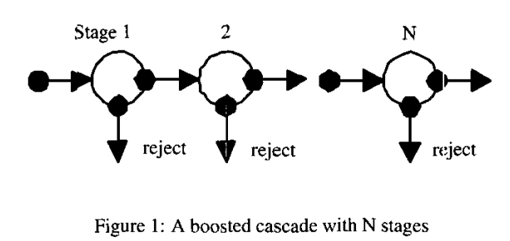
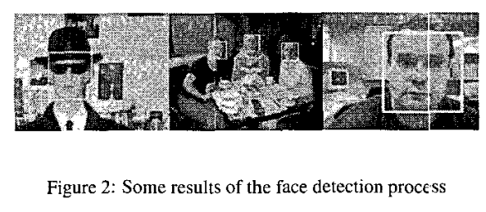
Eye Detection:
The eyes are assumed to be the darkest areas on the face. The image is converted to grayscale and then to a binary format. Eye candidates are found using contour detection methods. Geometric criteria such as the distance between the found points and whether they are on the same horizontal line are used to confirm that they are “eyes.”
After the eyes are detected, the “Optical Flow” method is applied to measure the activity in these areas.
- Blinking: The movement of pixels in the eye area is used to measure whether the eye is open or closed, or to measure the blinking rate.
- Head Movement: At the same time, it is tracked whether the driver is nodding or shaking their head, or whether their head remains still.
- Monotony: Staring without blinking for a long time (“stare glance”) and complete cessation of head movements.
- Fatigue: Frequent blinking, eyes remaining closed for a long time, or head nodding forward (signs of drowsiness)..

Night Vision:
The infrared (IR) blocking filter in the camera has been removed, and infrared LEDs with a wavelength of 870nm, invisible to the human eye, have been installed inside the vehicle. This allows the system to track faces and eyes even in pitch darkness.

Input:
Real-time video frames from a standard webcam (Philips Vesta Pro or Kodak DVC 325).
Light from 28 infrared LEDs with a wavelength of 870nm, invisible to the human eye, for operation in the dark.

Output:
Blink rate, duration of eyes closed, and amount of head movement.
Determining whether the driver is “Fatigued” or experiencing “Monotony”.
A visual/audible alarm triggered when blinking does not occur for a certain period of time (fixed gaze/stare glance) or when head movement stops.

Strengths:
To achieve a good cost-performance ratio, it uses standard equipment, has a fast calculation time, can measure in the dark, and takes monotony into account.
It does not require any sensors attached to the driver. So the driver's comfort is not reduced.

Limitations:
there may not be an adequate number of images which are labeled.
The brightness controller of the webcam has to be closed.

Performance:
Despite its low frame rate (5 FPS), the system provides reliable tracking in everyday driving scenarios (day/night, glasses/hat) and keeps errors to a minimum.

Differences:
While most existing systems focus only on “fatigue/drowsiness,” this system also diagnoses “monotony”.
Other systems are very expensive and require specialized cameras, whereas this system works with standard webcams and PCs.
It does not require attaching EEG or EOG sensors to the driver, thus not compromising the driver's comfort.
Standard cameras have been modified by removing IR filters, enabling operation in pitch darkness.

Contributions:
It combines fatigue and monotony symptoms into a single visual monitoring system.
Using a “coarse-to-fine” strategy, it enables complex image processing to run even on low-performance hardware.
It has incorporated the parameters “fixed gaze” and “motionless head” into the system as the main indicators of monotony, in accordance with the literature.
It has proven that modified, inexpensive web cameras can be used for driver monitoring instead of expensive thermal or night vision cameras.

5-Driver Drowsiness Detection System Based on Eye State Analysis Pavilaa. C , Abitha. R , Sai Varshini. D , Mrs. D. Rajeswari

Purpose:
The Driver Drowsiness Detection System, utilizing eye state analysis, introduces an innovative approach with OpenCV for real-time monitoring of eye movements.This combination enables precise eye tracking and analysis, essential for assessing driver alertness.

Dataset:
The dataset comprises real-time captured images and video sequences that record varying degrees of drowsiness in drivers, under diverse lighting and head movement conditions.

Model Structure:
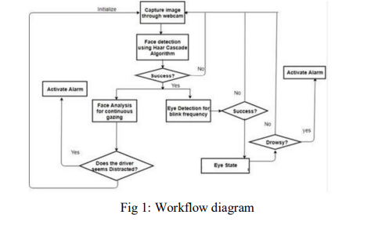
The drowsiness detection system operates by capturing real-time images of the driver’s face using a dashboard or steering wheel-mounted camera.
Various image processing algorithms are then employed to detect facial features like eyes, eyebrows, and mouth.
The system architecture involves capturing images via a webcam, detecting faces using the Haar cascade algorithm, and subsequently identifying eyes for blink frequency assessment. The system then determines drowsiness based on eye closure frequency and alerts the driver accordingly. In this module, the system employs a modified Convolutional Neural Network architecture to assess the severity of detected drowsiness.
The neural network is specifically designed to analyze extracted features from the driver’s eyes, aiming to provide a nuanced evaluation of the drowsiness level.
By incorporating the modified CNN architecture, the drowsiness detection system gains a layer of sophistication, enabling a more refined and accurate assessment overall.

Input:
The input to the system is a real-time video stream captured by a camera positioned towards the driver’s face.

Output:
Driver status (Normal / Drowsy / Sleepy)
Drowsiness Score
Audible alarm or visual warning

Strengths:
High accuracy (93%+) with EAR + CNN combination
Minimal impact from head position changes
Lightweight CNN structure adaptable to embedded systems
Hardware independent, camera-based solution only

Limitations:
The system’s performance may be impacted by occlusions such as sunglasses or intense lighting, which hinder accurate eye detection.
CNN requires a GPU for real-time operation. Performance
The model achieved 93% accuracy and a 91% F1-score.

Contributions and Key Differences:
The developed algorithm is integrated into a real-time monitoring system capable of continuously analyzing driver behaviour.
When the system detects signs of drowsiness, an alert mechanism is triggered to notify the driver.
The proposed system contributes to road safety by providing an automated, real-time alert solution that minimizes human error.

6- Non-Intrusive Driver Drowsiness Detection – Bamidele, A. & Kamardin, K. (2019)

Purpose:
The main objective of this paper is to develop a non-intrusive driver drowsiness detection system that utilizes facial and eye features to determine the state of the driver.The system aims to prevent road accidents by detecting early signs of drowsiness and providing timely alerts.

Datasets:
The system was tested using video recordings of drivers in simulated driving environments.The dataset includes face and eye image sequences of both drowsy and non-drowsy subjects captured in various lighting conditions.The facial images were annotated manually to indicate the eye state—open or closed—for training and validation purposes.

Input:
The input to the system is a live video feed of the driver’s face captured using a standard webcam placed in front of the driver.The captured frames are converted to grayscale and preprocessed to reduce noise before feature extraction.The system continuously monitors the driver’s eyes to compute parameters such as eye closure percentage and blink duration.

Output:
The system generates an alert signal when prolonged eye closure is detected beyond a defined threshold.The final output is a visual or audio warning to the driver indicating the onset of drowsiness.The alert is triggered only when the system consistently classifies the driver as drowsy across several consecutive frames.

Model Structure:
The proposed system employs computer vision and machine learning algorithms to detect the driver’s face and eyes.Haar cascade classifiers are used for face and eye detection due to their speed and accuracy in real-time applications.From the eye states, three important drowsiness features were extracted: percentage of eyelid closure (PERCLOS), blink frequency, and maximum closure duration of the eyes.These features were then fed as inputs into several machine learning models for drowsiness classification.The classifiers evaluated include Support Vector Machine, Random Forest, and K-Nearest Neighbour.The model with the best performance was chosen as the final classifier for the system
Random Forest was used in the system's output decision module.

Strengths:
The system is non-intrusive, requiring no physical contact with the driver.It uses a standard webcam, making it cost-effective and easy to deploy in vehiclesThe approach achieves accurate and efficient detection with minimal computational resources.

Limitations:
The accuracy of the system may decrease under poor lighting conditions or when the driver wears sunglasses.Facial occlusions and rapid head movements may also lead to false detections.

Performance:
Experimental results show that the Random Forest classifier achieved the highest accuracy among the tested models.The system was able to detect drowsiness with an accuracy of 92.3% under normal lighting conditions.The proposed approach provides reliable real-time performance suitable for practical implementation.

Contributions and Key Differences:
This research demonstrates that non-intrusive systems using computer vision can achieve comparable accuracy to intrusive EEG-based systems. By combining multiple visual features such as PERCLOS, blink frequency, and closure duration, the system improves robustness and reduces false alarms.The study contributes to the field by emphasizing the feasibility of using simple, low-cost sensors for real-time drowsiness detection.

7-Driver Drowsiness Detection Using Hybrid Model CNN and LSTM – Dipti, Amandeep, Sumit, Arjoo

Purpose:
The main objective of this research work is to develop a driver drowsiness detection system that uses hybrid deep learning models to detect drowsiness in real-time.The proposed system aims to prevent accidents caused by fatigue by monitoring the driver’s facial and eye movements.To improve accuracy, CNN and LSTM models are combined to extract both spatial and temporal features from the video frames.

Datasets:
The dataset used in this work is the MRL Eye Dataset, which contains a total of 84,898 images of eyes with variations in lighting, gender, and ethnicity.It includes images with different eye states such as open, closed, and partially closed.The dataset was divided into training, validation, and testing sets in an 80:10:10 ratio.

Input:
The input to the system is a live video stream captured from a camera mounted in front of the driver.

Output:
The output of the model is a classification of the driver’s state into three categories: alert, drowsy, and sleeping. An alarm signal is generated when the model detects the drowsy or sleeping state for several consecutive frames.

Model Structure:
The proposed model architecture combines Convolutional Neural Networks for spatial feature extraction and Long Short-Term Memory networks for temporal sequence learning.The CNN model processes the input eye images to extract relevant spatial features that represent the shape, texture, and structure of the eye region. It consists of multiple convolutional layers followed by ReLU activation functions and max-pooling layers to down-sample feature maps. The CNN is trained on preprocessed eye images of size 48×48 pixels. After convolution and pooling, the feature maps are flattened and passed as input to the LSTM layer. The LSTM layer is responsible for capturing temporal dependencies between consecutive frames to model the transition between alert, drowsy, and sleeping states. The hybrid architecture enables the system to analyze both the spatial information in individual frames and the temporal sequence of eye movements over time. The CNN and LSTM layers are followed by fully connected dense layers for final classification. The output layer uses the Softmax activation function to classify the driver’s state into three categories: alert, drowsy, and sleeping. The architecture was implemented using TensorFlow and Keras libraries, and trained using the Adam optimizer with categorical cross-entropy loss. Batch normalization and dropout layers were added between convolution and dense layers to prevent overfitting and improve generalization. The model was trained for 50 epochs with a batch size of 32 to achieve optimal accuracy. By combining CNN and LSTM, the hybrid model effectively integrates spatial feature extraction with sequential learning to improve detection accuracy.
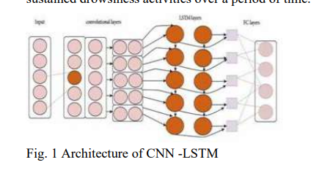

Strengths:
The hybrid CNN-LSTM model captures both dimensional and temporal information, improving detection accuracy. The use of a large dataset with varied lighting and demographic conditions enhances model robustness.

Limitations:
The system’s performance decreases under extreme lighting conditions, especially during nighttime driving. Head movements or partial face occlusion can affect the detection of eye states. The system is limited to front-facing cameras and may not perform well if the driver’s face is not directly visible.

Performance:
The proposed hybrid CNN-LSTM model achieved an accuracy of 97.1% on the MRL Eye Dataset. When compared with other models, CNN achieved 91.6%, LSTM 82.4%, and ResNet50V2 achieved 99.71%.

Contributions and Key Differences:
The proposed work contributes to driver safety by integrating deep learning models that analyze both eye and facial features in real-time.Unlike traditional systems that rely only on static image analysis, this hybrid approach considers temporal variations in eye behavior.The study demonstrates that combining CNN and LSTM enhances model accuracy and reliability for practical applications.

8-Deep Learning-Based Real-Time Driver Cognitive Distraction Detection – Matteo Fresta et al., IEEE Access, 2025

Purpose
The goal of this study is to develop a driver cognitive distraction detection system with real-time performance, exploring deep learning models specifically designed for time-series processing.The system aims to classify distraction from vehicular,
eye-tracker, and physiological signals without manual feature engineering.

Datasets:
Data were collected from 42 subjects in a driving simulator during a Twenty-Question Task (TQT) designed to induce cognitive distraction. Signals were acquired at 60 Hz from the simulator, 60 Hz from a 5-camera Smart Eye Pro eye-tracking system, and 2000 Hz from ECG and EDA sensors. The dataset includes 12 features for 162,800 samples labeled as distracted or not-distracted (50%-50%).

Input:
Input features include vehicular data, eye-tracker data, and physiological data (heart rate, electrodermal activity).

Output:
The model outputs a binary classification: ‘distracted’ or ‘not distracted’ for each 0.5-second time window.

Model Structure:
The proposed deep learning-based framework was designed to process multimodal data streams from vehicular, physiological, and eye-tracking sensors in real-time.The input data consist of synchronized and downsampled signals from three modalities: vehicular (speed, steering, acceleration), physiological (EDA, ECG), and eye-tracking (pupil diameter, eye position, head pitch).All signals were aligned to a common sampling frequency of 60 Hz and segmented into fixed-length overlapping windows of 0.5 seconds for analysis. Each time window was treated as a multivariate sequence and fed into one of the tested deep learning architectures, namely 1D-CNN, MiniRocket, WaveNet, Transformer, and ResNet-18.The 1D-CNN architecture consists of convolutional layers with kernel size 3, followed by batch normalization, ReLU activation, max pooling, and fully connected layers.
The MiniRocket model uses random convolutional kernels and aggregation functions to create high-dimensional representations of temporal patterns.
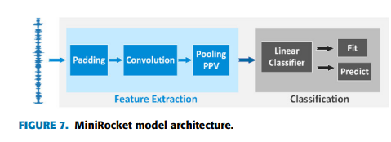
WaveNet leverages dilated causal convolutions and residual blocks to capture both short-term and long-term dependencies in the time series.
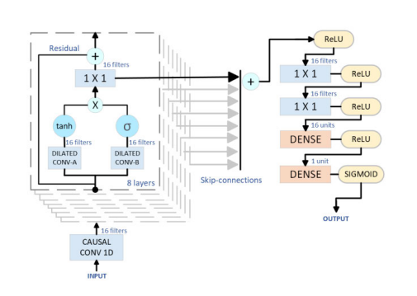

The Transformer architecture applies positional encoding and multi-head attention with 8 heads and embedding dimension 128, enabling the model to focus on the most relevant temporal regions
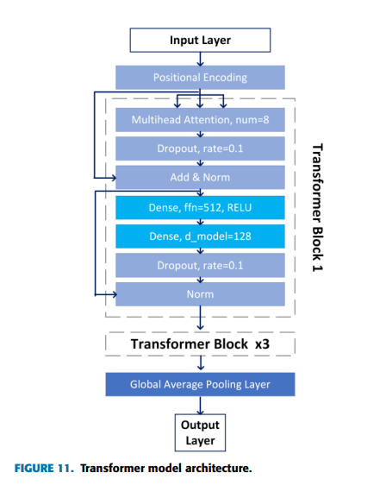

ResNet-18 architecture includes 18 convolutional layers with skip connections, batch normalization, and ReLU activation to mitigate gradient vanishing and overfitting.
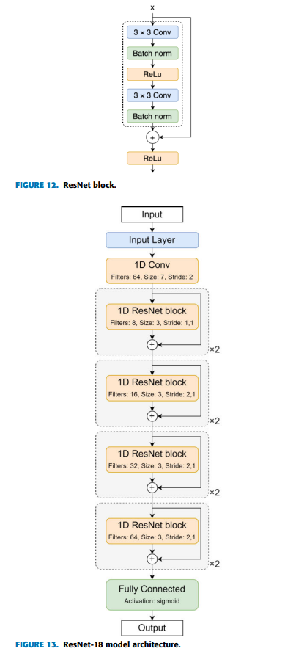
All models were trained using the Adam optimizer with a learning rate of 0.001 and binary cross-entropy loss function.Early stopping and dropout (p = 0.3) were applied to prevent overfitting.The output layer used a sigmoid activation function, producing the probability of the cognitive distraction state.To ensure interpretability, the Shapley Additive Explanations (SHAP) framework was applied to analyze feature importance across input modalities.The SHAP analysis revealed that vehicular parameters such as accelerator position, lateral velocity, and steering torque had the highest impact on model decisions, followed by eye position and head pitch.

Strengths:
Deep learning models outperformed shallow ML models by learning features directly from raw data. Vehicular data proved fundamental for system performance and robustness against sensor failure. The proposed models can classify time-windows as short as 0.5 seconds, enabling real-time operation. Deployment tests on Raspberry Pi 5 and Jetson Nano confirmed feasibility for embedded, in-vehicle use.

Limitations:
Physiological data (EDA, HR) are prone to inter-individual variability and signal loss. Fine-tuning per driver improves accuracy but reduces generalization across users. Real-world variability and environmental factors remain untested beyond simulation.

Performance:
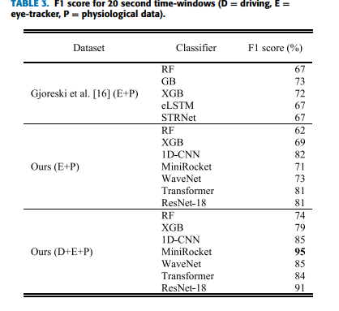

Contributions and Key Differences
This is the first study to combine vehicular, physiological, and eye-tracker data in a unified deep learning framework for cognitive distraction detection.It introduces SHAP-based explainability to quantify the influence of each signal type. The system’s low latency, high interpretability, and embedded deployment readiness represent a step toward real-time, in-vehicle cognitive distraction monitoring.

9-Real-Time Drowsiness Detection Using Eye Aspect Ratio and Facial Landmark Detection – Varun Shiva Krishna Rupani et al.

Purpose:
This study presents a real-time system designed to detect drowsiness using the Eye-Aspect-Ratio (EAR) and facial landmark detection techniques.By establishing a threshold for the EAR, the system identifies when eyes are closed, indicating potential drowsiness.The process involves capturing a live video stream, detecting faces in each frame, extracting eye landmarks, and calculating the EAR to assess alertness.

Datasets:
We utilize a comprehensive dataset that combines images from the MRL and Closed Eyes in Wild (CEW) datasets along with our unique dataset. Version 1 consists of 10,000 images (5,000 open and 5,000 closed), while Version 2 includes 5,000 images (2,500 each). Similarly, Versions 3 and 4 contain additional collections of 10,000 and 4,000 images, respectively.The dataset includes a variety of eye images designed to enhance the performance of drowsiness detection algorithms.

Input:
The data collection process involves capturing live video streams using a standard webcam.

Output:
The system checks if the EAR falls below a predetermined threshold for a specified number of consecutive frames.If the EAR remains below the threshold for the required number of frames, an alert message is displayed on the screen. This alert serves as a warning to the user that they may be drowsy and should take appropriate action.

Model Structure:
The system uses Dlib’s pre-trained shape predictor model to accurately detect and monitor 68 facial landmarks.The Eye Aspect Ratio (EAR) is calculated using Euclidean distances between specific points around the eyes.When the eyes are open, the EAR is relatively high; when the eyes are closed, the EAR decreases significantly.The average of both eyes’ EAR values is used to improve reliability and minimize noise.The system utilizes OpenCV for real-time image processing, Dlib for facial landmark detection, and Python as the core programming environment.Threshold determination was done through empirical analysis, setting the EAR threshold to 0.25 and frame check parameter to 20 frames.

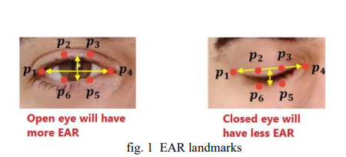
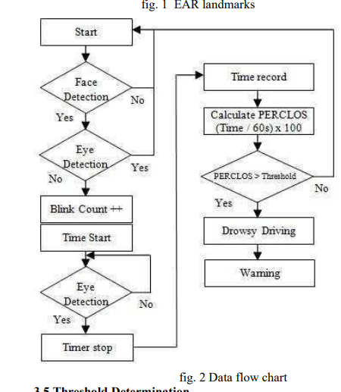

Strengths:
The system reliably detects drowsiness with high accuracy while maintaining low computational demands.It performed effectively across diverse lighting conditions and individual facial variations.The implementation demonstrates real-time processing capability, suitable for real-world deployment.

Limitations:
Performance degradation was observed in low light and nighttime conditions.

Performance:
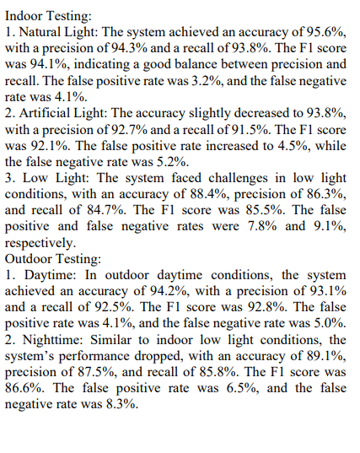
Contributions and Key Differences:
This research presents a non-intrusive, real-time solution for detecting drowsiness in practical applications such as driver monitoring and workplace safety.The methodology for calculating EAR from facial landmarks provides a foundation for future development.The system demonstrates robustness across facial variations and real-time applicability.Future work will focus on improving lighting adaptation, mobile integration, and personalized calibration.

10-A Real-Time Driver Drowsiness Detection System Based on Facial Features and Deep Learning- ANK Zaman, Prosenjit Chatterjee, Rajat Sharma

Purpose:
This research develops a real-time driver drowsiness detection system utilizing deep convolutional neural networks (DCNNs) and OpenCV. The model takes real-time facial images of a driver using a live camera and utilizes OpenCV to examine facial images for facial landmarks like sufficient eye openings and yawn-like mouth movements.

Datasets:
We utilized two publicly available datasets named NTHU-DDD and Yawn-Eye-Dataset.The NTHU-DDD dataset consists of 66,521 images incorporating 36 subjects recorded under various conditions such as everyday driving, yawning, slow blinking, and falling asleep.The Yawn-Eye-Dataset consists of 4 target classes: Closed, No Yawn, Yawn, and Open.

Input:
The system utilizes a real-time live camera to capture facial images of the driver at regular intervals.All images were resized into 96x96 resolution for CNN input.

Output:
When drowsiness is detected, the system triggers a warning alert, helping to prevent accidents and improve road safety.Figure 3 shows that when the subject exhibits either or all of the facial expressions like eyes-closed and yawning, the system triggers a warning signal.
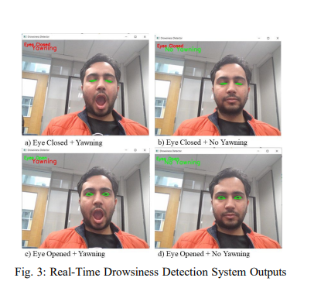

Model Structure:
The convolutional neural networks (CNNs) model employed in this experiment comprises two convolutional layers followed by max-pool layers, a flattening layer, a dense (fully connected) layer, a dropout layer, and an output layer.The first convolution layer uses 32 filters with a 5×5 kernel size, producing a 94×94×32 feature map, which is then reduced to 47×47×32 through a 2×2 max-pool layer.The second convolutional layer applies 64 filters with a 3×3 kernel, resulting in a 45×45×64 feature map that is subsequently reduced to 22×22×64 by another 2×2 max-pool layer.The output of these convolutional operations is flattened into a one-dimensional tensor of 30,976 units and passed into a dense layer with 128 units.A dropout layer follows the dense layer to reduce overfitting, ensuring better generalization.The final dense layer provides a 4-unit output for classification tasks.Rectified Linear Unit (ReLU) activation is used in hidden layers, while Sigmoid activation is applied for 2-class classification (NTHU-DDD) and SoftMax activation for 4-class classification (Yawn-Eye Dataset).Figure 2 visually represents the implemented DCNNs model.
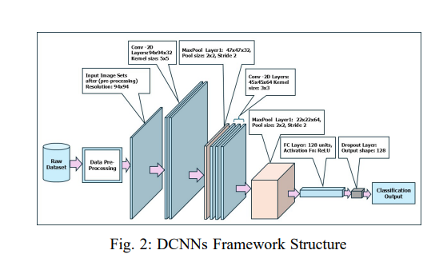
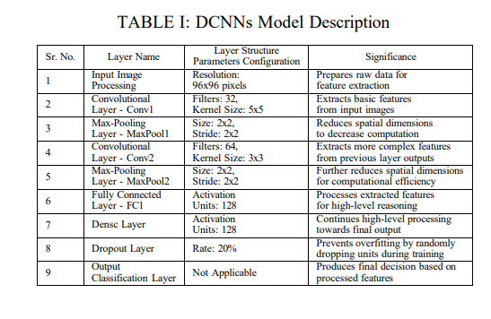
In preprocessing, all dataset images were resized to a 96×96 resolution for CNN input.The implemented CNNs offer a practical, real-time approach for detecting drowsy drivers based on deviations of facial traits from normal to drowsy.

Strengths:
The model features a lighter layer structure without compromising its robust classification capabilities.This streamlined, pretrained model enables quicker responses in real-time applications.The system demonstrates a reliable real-time drowsiness detection with a low rate of false alarms.

Limitations:
It might not function well in very low luminance or if the facial sensor capture device is restricted.Further research can be conducted incorporating infrared camera sensors for better precision and robustness.

Performance:
The proposed model achieved 99.6% test accuracy on the NTHU-DDD dataset and 97% test accuracy on the Yawn-Eye-Dataset.Precision, recall, and F1-score for the NTHU-DDD dataset were all approximately 1.00, indicating a nearly perfect classification performance. For the Yawn-Eye-Dataset, accuracy was recorded as 0.96 with a macro average F1-score of 0.96.

Contributions and Key Differences:
The proposed system uses DCNNs and OpenCV frameworks, and utilizes facial features like eye opening/closing and yawning to identify drowsiness for a low-cost effective solution.Compared to recently implemented models, the proposed system achieves significantly higher accuracy and fewer false alarms.

Method

Dataset

Video Standardization Processes Performed with FFmpeg
Some videos are not supported by standard media players due to the encoding profile used. Therefore, even though the files are not corrupted, they cannot be opened directly on a computer.
Using FFmpeg, the encoding structure of the videos was analyzed and converted to a standard format. In this context, the videos were re-encoded with the H.264 (libx264) codec, the pixel format was set to yuv420p (4:2:0), and the frame rate was fixed at 30 FPS to ensure consistency in the analysis. Since audio data was not used in the analysis process, the audio channel was removed. The converted videos were recreated with the _std.mp4 extension within the same folder structure, preserving the original files, and all processes were automatically applied, including subfolders. As a result of this process, the dataset has been made fully compatible with both standard media players and image processing tools such as OpenCV and PyMovements.

The command used to convert all MP4s:


Separation and Resizing of Mosaic Videos
Some video recordings in the Driver Monitoring Dataset are presented in a 2×2 mosaic format, where four different camera images are combined into a single frame. This structure makes it difficult to process the driver's face area directly and can negatively affect the accuracy of face/landmark detection algorithms.
Therefore, the following steps were applied during the data preprocessing phase:
• Mosaic videos were split into two frames,
• The lower-left region where the driver is located was selected,
• The selected panel was separated from its original size (640×360),
• It was then rescaled to 1280×720 resolution for image quality and model compatibility.

Code:
This code was used to extract the driver's left-bottom panel (Panel 2) from the 2×2 mosaic format videos in the DMD dataset and convert it into a single image for analysis. The 1280×720 resolution videos in the mosaic structure were divided into two on a square basis to obtain a 640×360 driver panel.
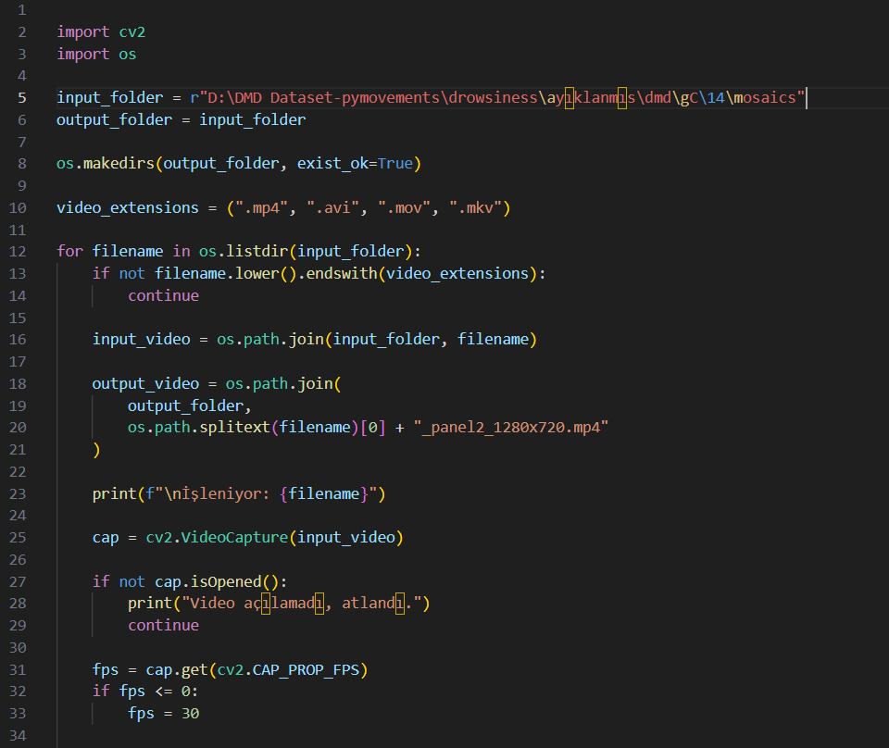
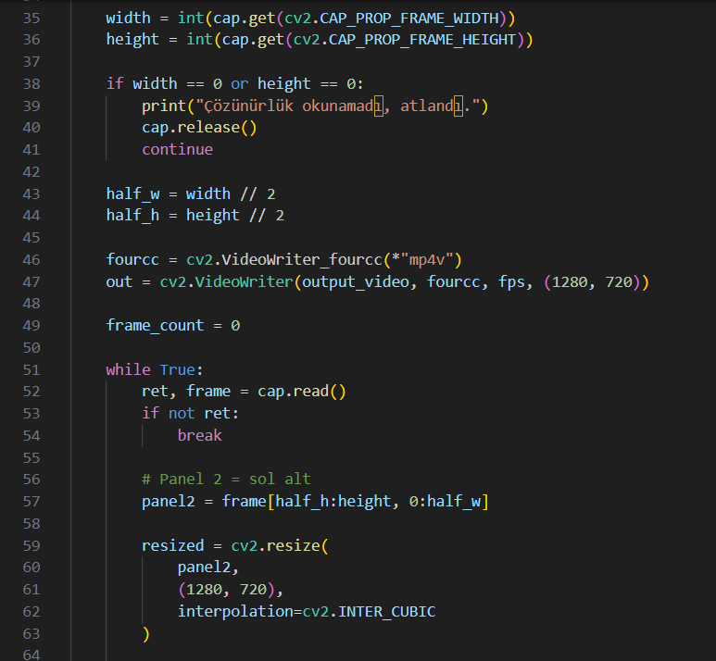
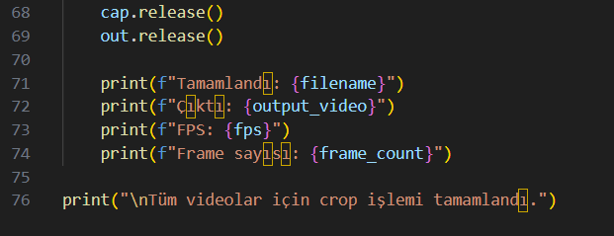

Input:
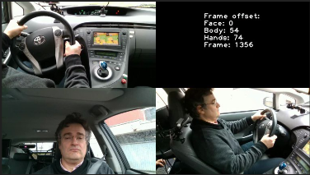
Size: 1280×720

Output:
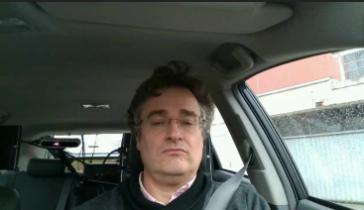
Size: 1280×720

Face Detection

Face detection is a computer vision technique that automatically detects human faces within an image or video. This method identifies the area of a face within an image, allowing the system to perform analysis only on that specific region.

In this study, the face detection process was performed on video frames containing driver images. The face region is automatically detected on each frame obtained from the video stream, and the system performs its analysis only on this region. This prevents the analysis of background areas or regions unrelated to the driver in the image.

Reason for Using Face Detection in the Project
The primary reason for using face detection in this project is to accurately identify the driver's facial region and extract the necessary behavioral characteristics from this region. In driver monitoring systems, it is necessary to analyze face-based features such as the driver's eye movements, eye openness ratio, and head position in order to detect conditions such as drowsiness and distraction. After face detection, numerous landmark points on the face were determined using the MediaPipe FaceMesh algorithm. These landmark points represent the geometric positions of areas such as the eyes, nose, mouth, and facial contour. Specifically, the Eye Aspect Ratio (EAR) value is calculated using the landmark points around the eyes, and the driver's eye openness is analyzed.

Code:
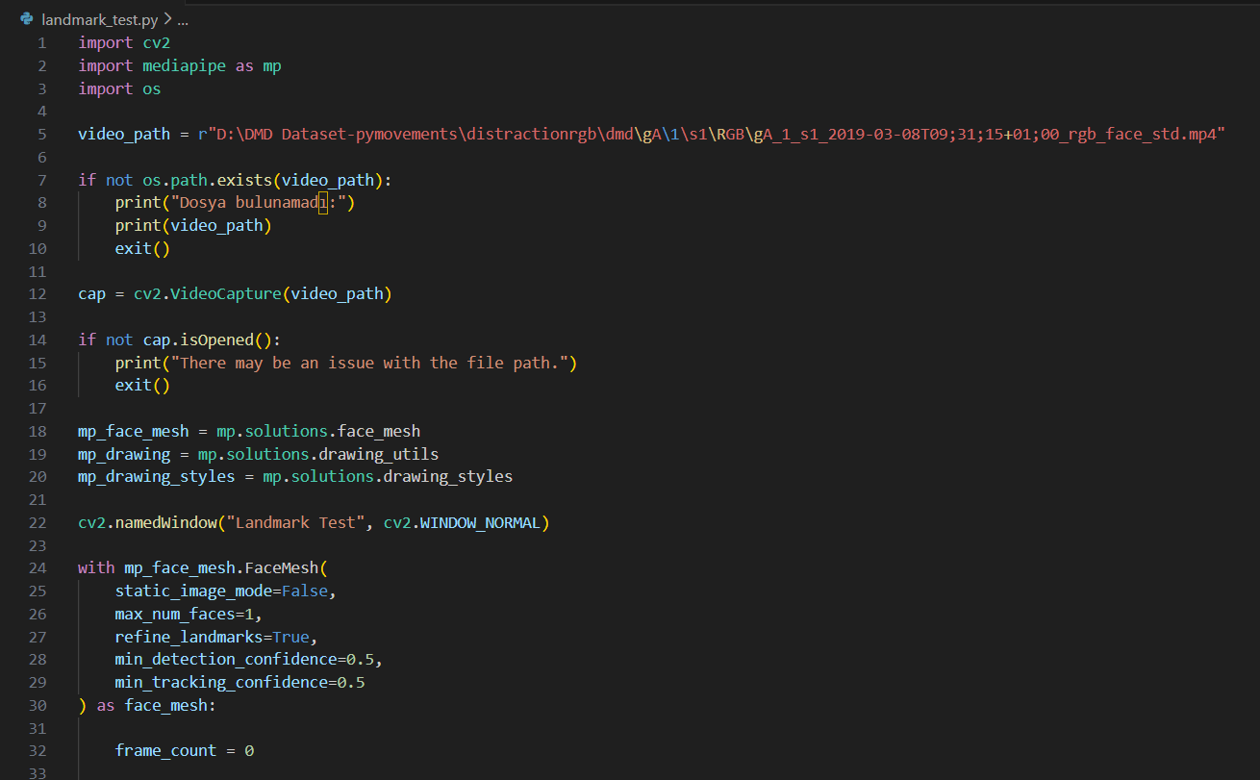
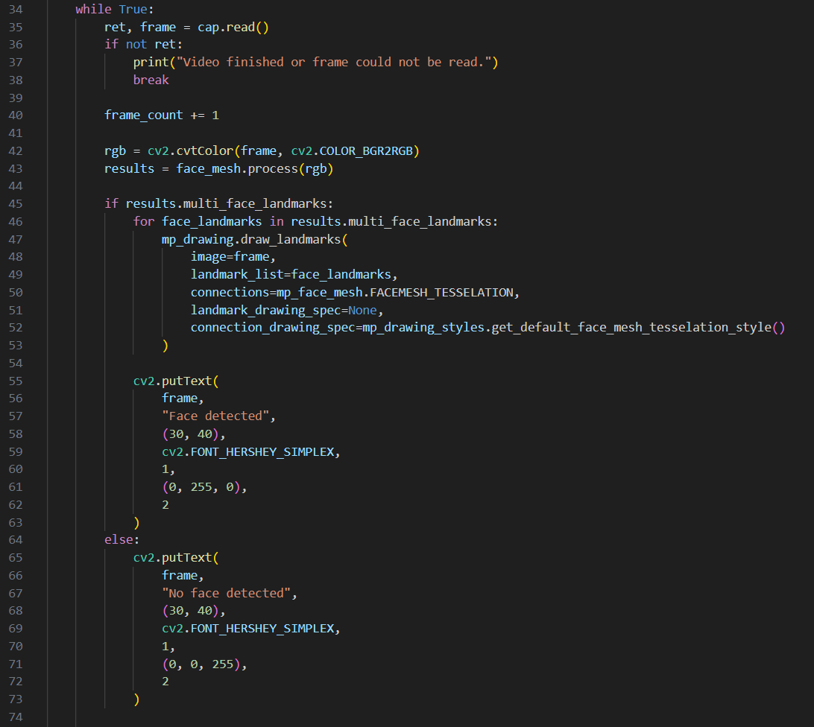
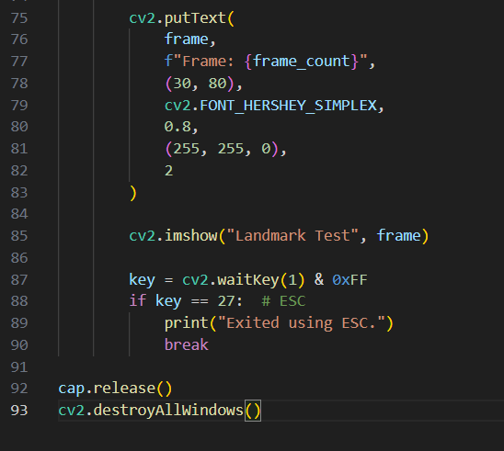
Input:
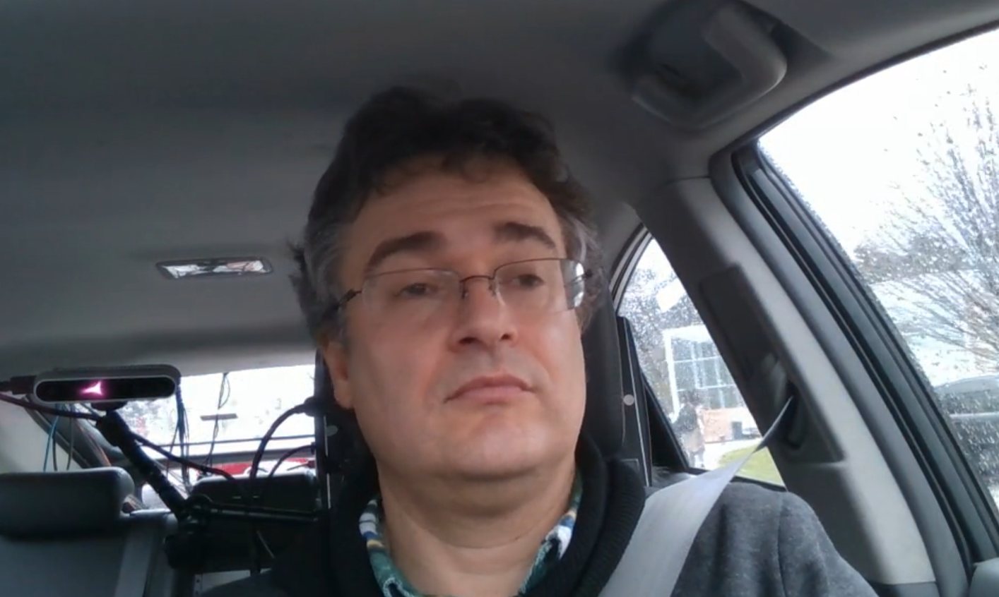

Output:
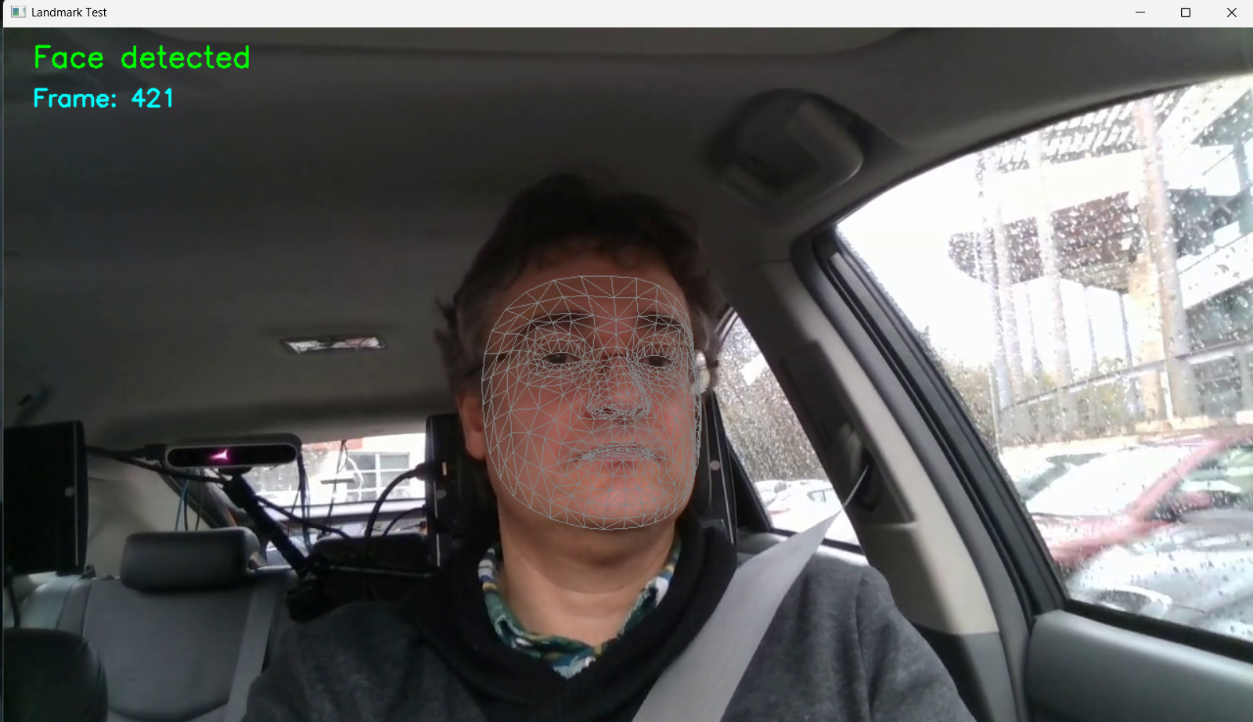

Eye Detection and Eye Aspect Ratio
Eye detection is the process of automatically identifying the eye region within a human face in the fields of image processing and computer vision. In this study, the eye detection process was performed using the FaceMesh model from the MediaPipe library. The FaceMesh model generates a total of 468 facial landmark points on a face. These landmark points represent different regions of the face. Specific indices belonging to the eye region were selected from among these points to obtain the eye landmarks.
- Landmark indices used for the left eye: 33, 160, 158, 133, 153, 144
- Landmark indices used for the right eye: 362, 385, 387, 263, 373, 380
Using these points, the geometric structure of both eyes was extracted and the eye area was visualized. Thus, the driver's eye region was automatically detected in every video frame. The eye detection stage provides the basic data for the eye aperture analysis and sleep detection to be performed in the subsequent steps of the system.
Eye Aspect Ratio (EAR) is a geometric measure used to determine whether the eye is open or closed. This method is based on the ratio of the distances between eye landmark points. The EAR value is calculated using the vertical and horizontal distances of the eye.
The EAR calculation formula is as follows:
EAR = (||p2 - p6|| + ||p3 - p5||) / (2 × ||p1 - p4||)
Here:
- p1 and p4 represent the horizontal endpoints of the eye.
- p2, p3, p5, and p6 represent the upper and lower points of the eye.
- ||pi - pj|| represents the Euclidean distance between two points.

When the eye is open, the vertical distance is large, so the EAR value is higher. When the eye is closed, the vertical distance decreases and the EAR value drops significantly. Therefore, the EAR value is an effective method for detecting blinking and eye closure.
The main purpose of using EAR in this project is to measure the driver's eye openness and detect the driver's drowsiness. One of the most commonly used methods for drowsiness detection in driver monitoring systems is PERCLOS (Percentage of Eye Closure) measurement. To calculate PERCLOS, it must first be determined whether the eye is open or closed. EAR is a highly reliable metric for making this distinction.
In this study, the EAR value was calculated using eye landmark points extracted by the MediaPipe FaceMesh model. First, the video data was read frame by frame using the OpenCV library. The MediaPipe FaceMesh model was run on each frame to obtain facial landmarks. Then, the indices corresponding to the eye region were selected from among the facial landmarks. Using these selected points, separate EAR values were calculated for the left and right eyes. Finally, the average of the EAR values calculated for both eyes was taken to obtain a single EAR value.

Code:
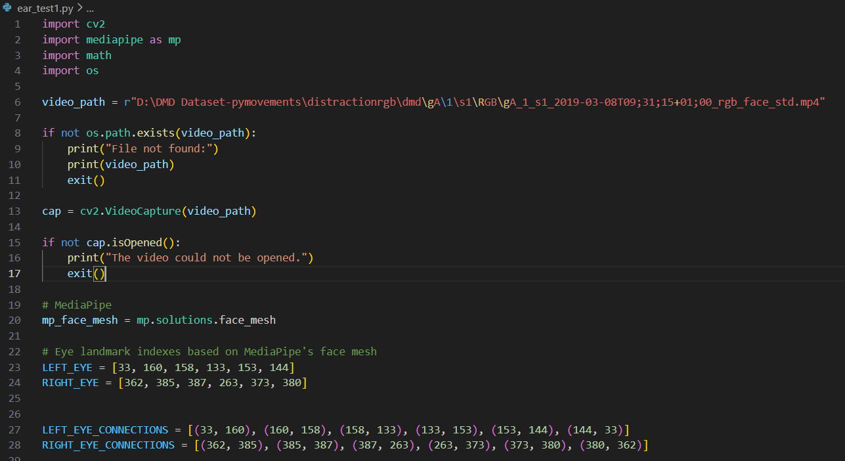
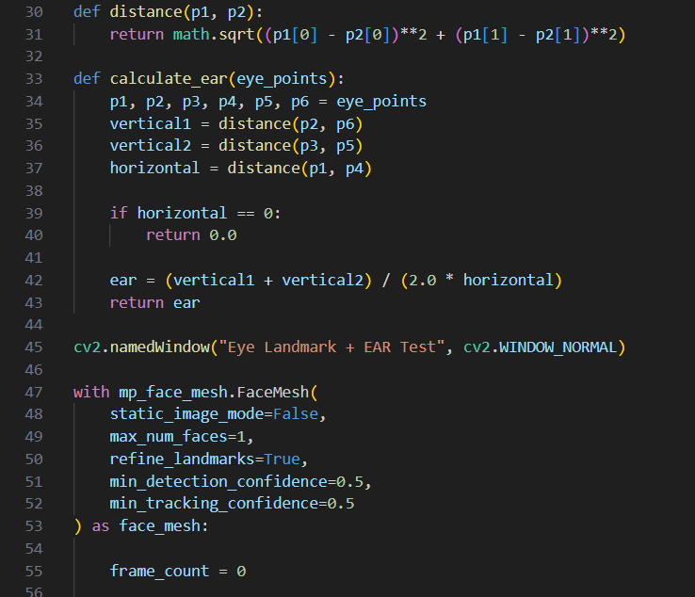
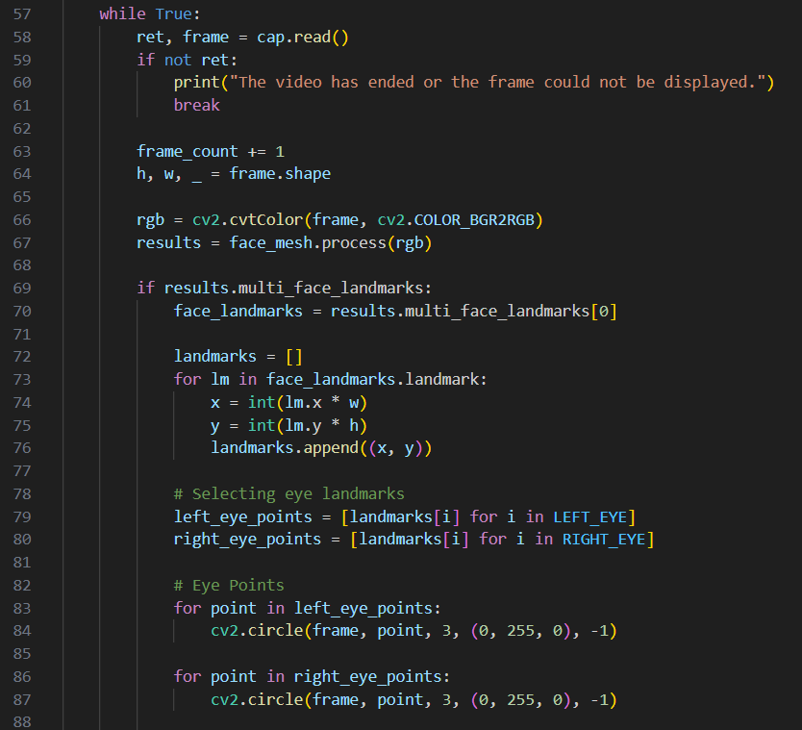
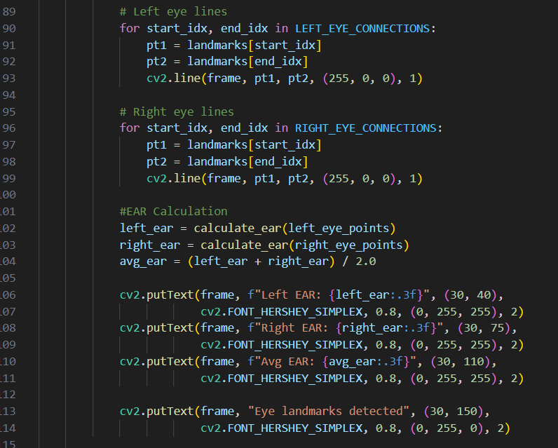
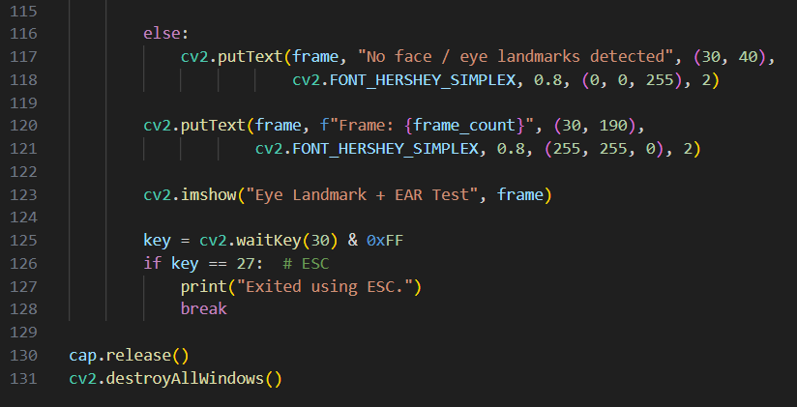

Outputs:
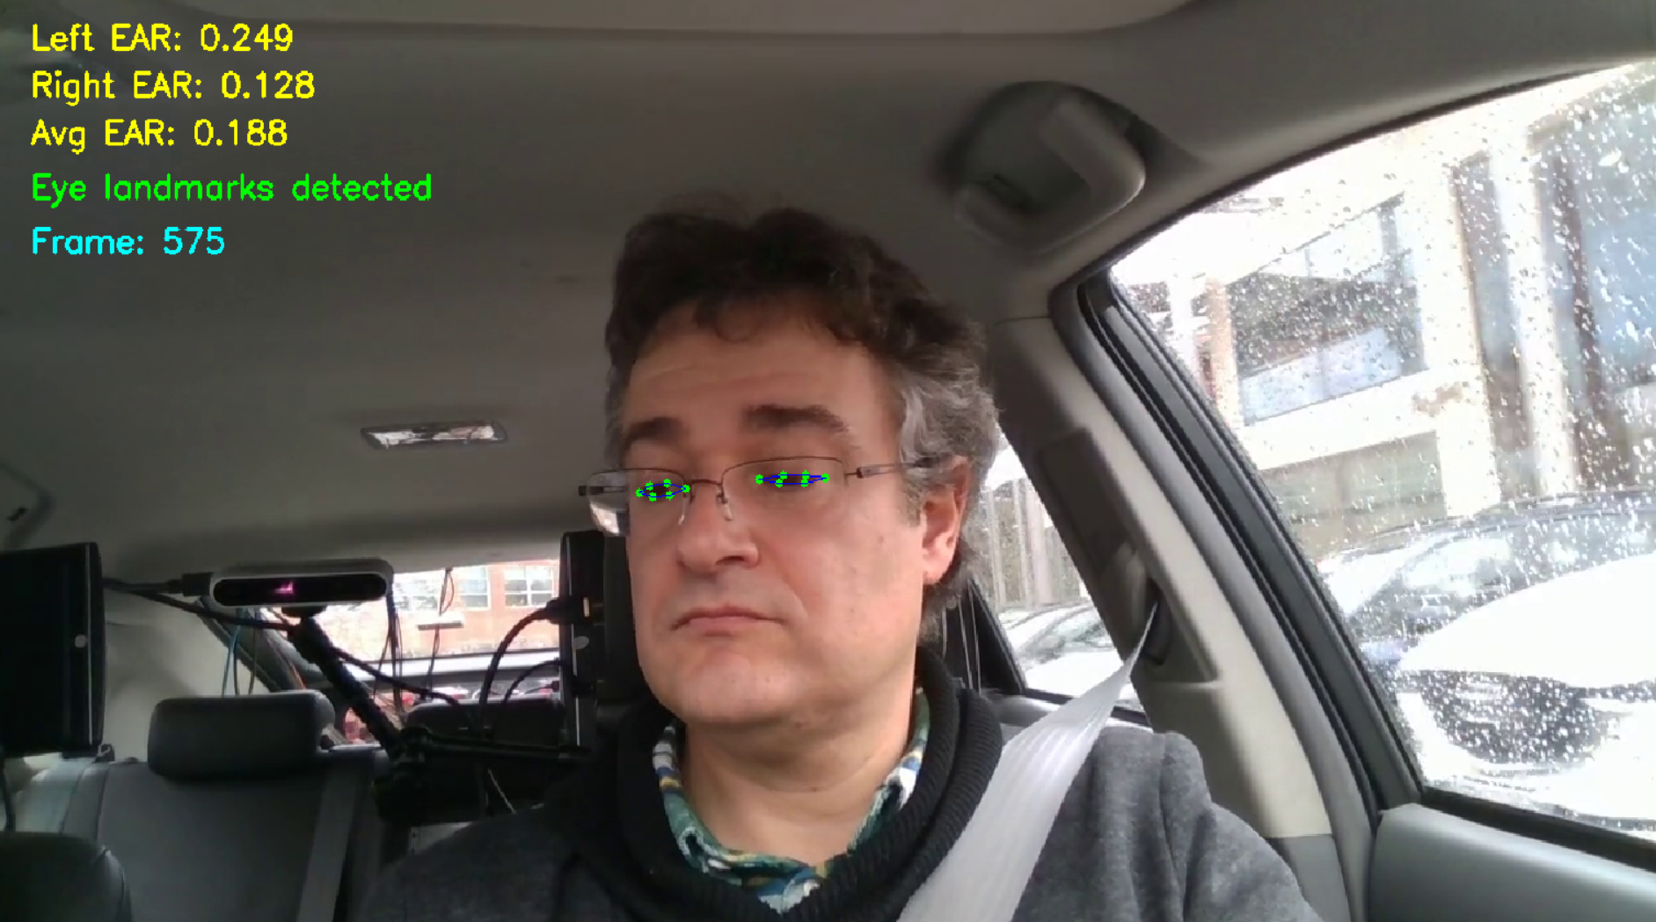
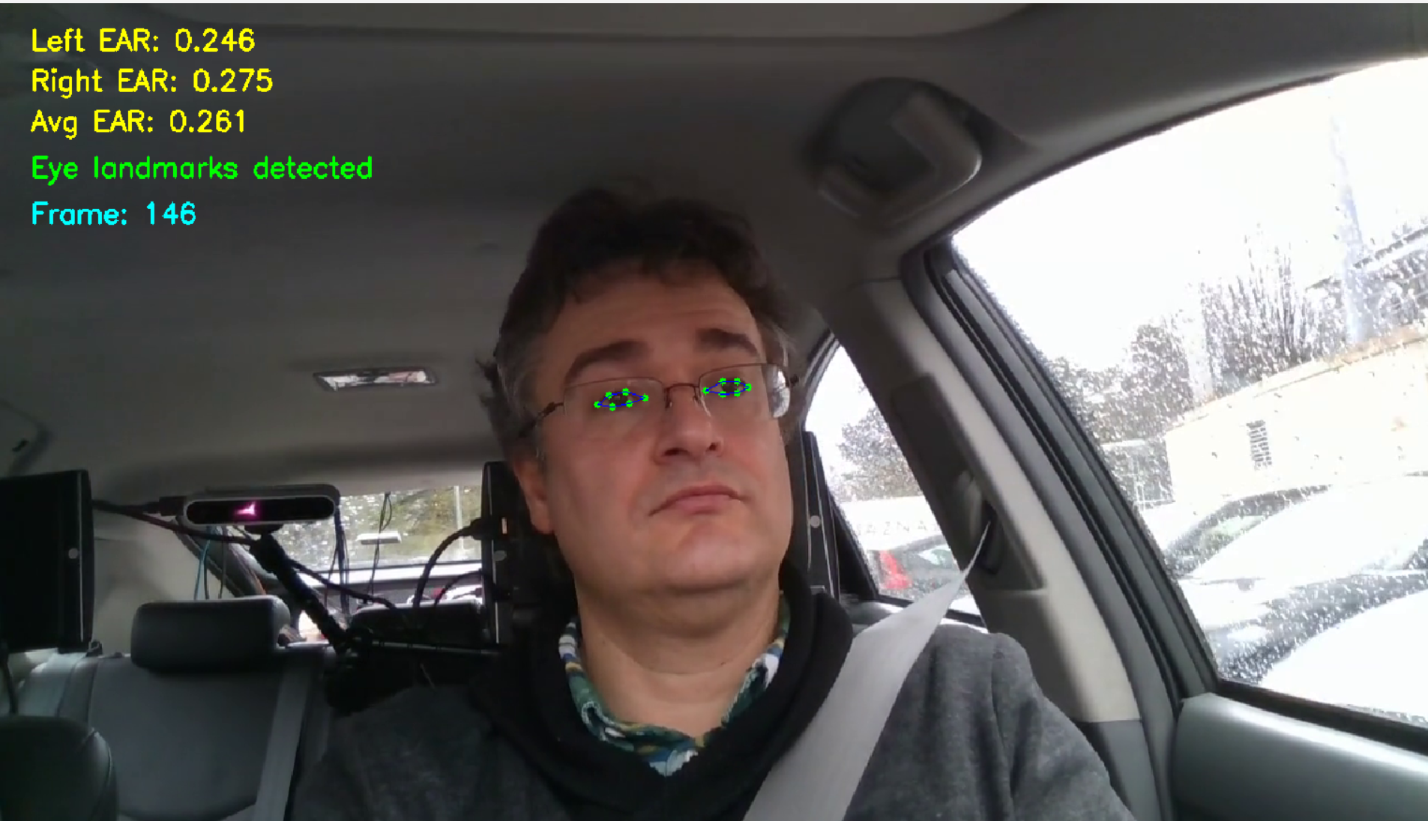

Head Pose Estimation
Eye openness alone is not sufficient to analyze the driver's attention state. Determining the direction of the driver's head is also an important indicator for detecting distraction.
The head pose estimation process is performed using specific landmarks on the face. These points are reference points that represent the geometric structure of the face and are automatically detected by the algorithm. In this study, the MediaPipe Face Mesh library was used to detect important points on the face. Specifically, the tip of the nose, the corners of the eyes, the corners of the mouth, and the chin point were used as reference points in the head pose calculation.
These obtained 2D image coordinates were matched with the approximate 3D model points of the face, and the head position was calculated using the Perspective-n-Point (PnP) algorithm.
As a result of this process, the head position is expressed in three basic angles:
- Yaw:
Indicates the angle of rotation of the head to the right or left.
Yaw > 0: looking to the right
Yaw < 0: looking to the left

- Pitch:
Indicates the upward or downward movement of the head.
Pitch > 0: head moving upward
Pitch < 0: head moving downward

- Roll:
Indicates the angle of head tilt to the right or left.
Roll ≈ 0: head is straight
Roll > 0: head is tilted to the right or left

The obtained yaw, pitch, and roll values are recorded for use in the driver's behavioral analysis.
The angle values obtained as a result of the head pose estimation process were displayed in real time on the video, and the accuracy of the driver's head movements was visually verified.

Code:
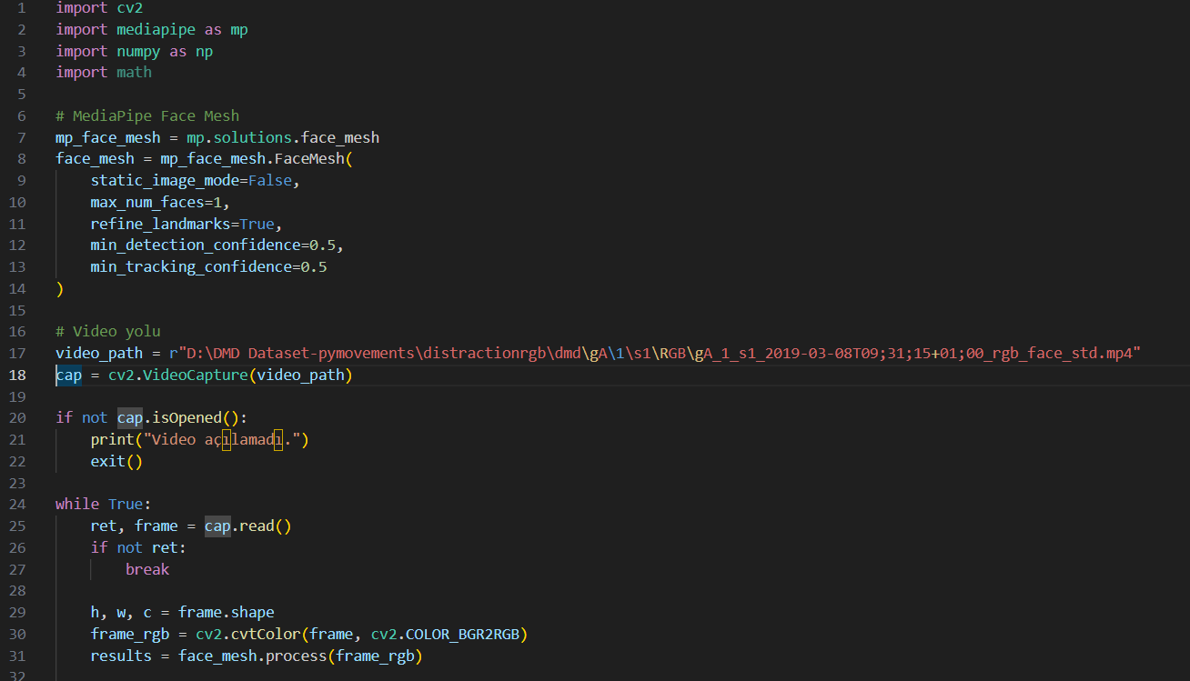
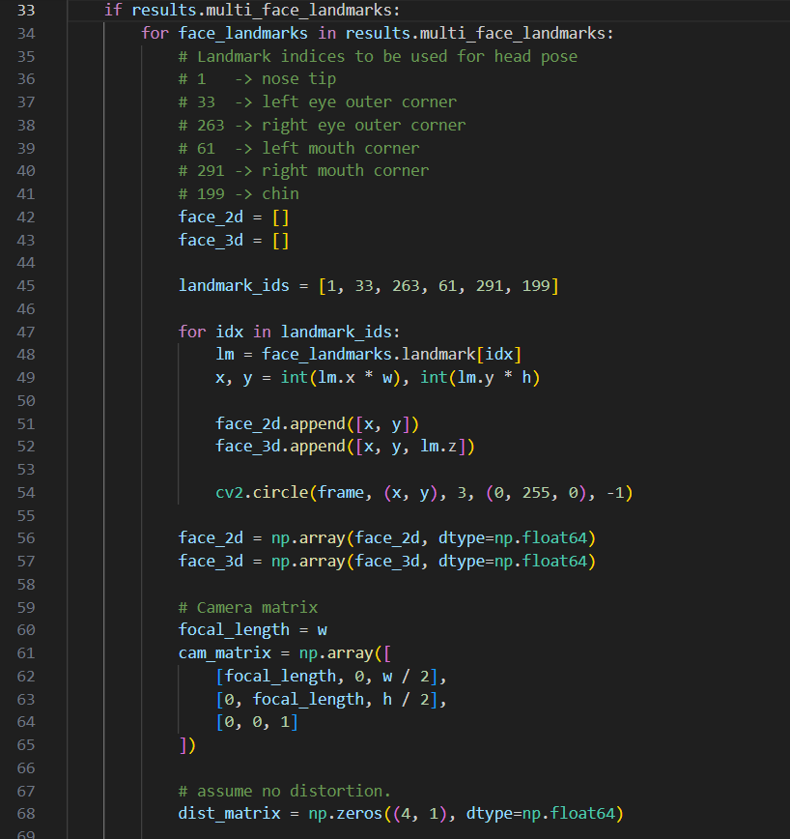

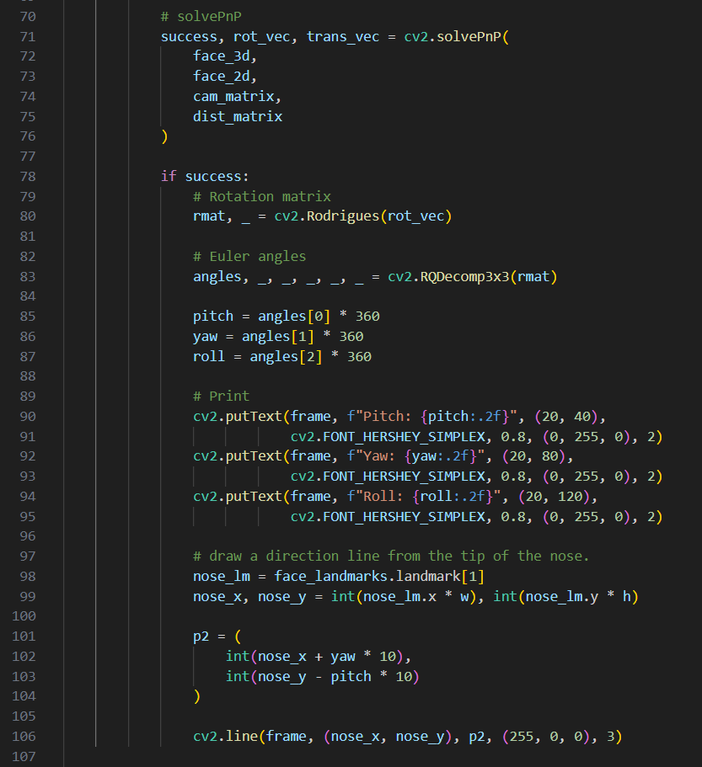

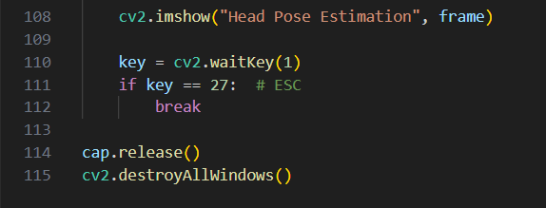

Output:
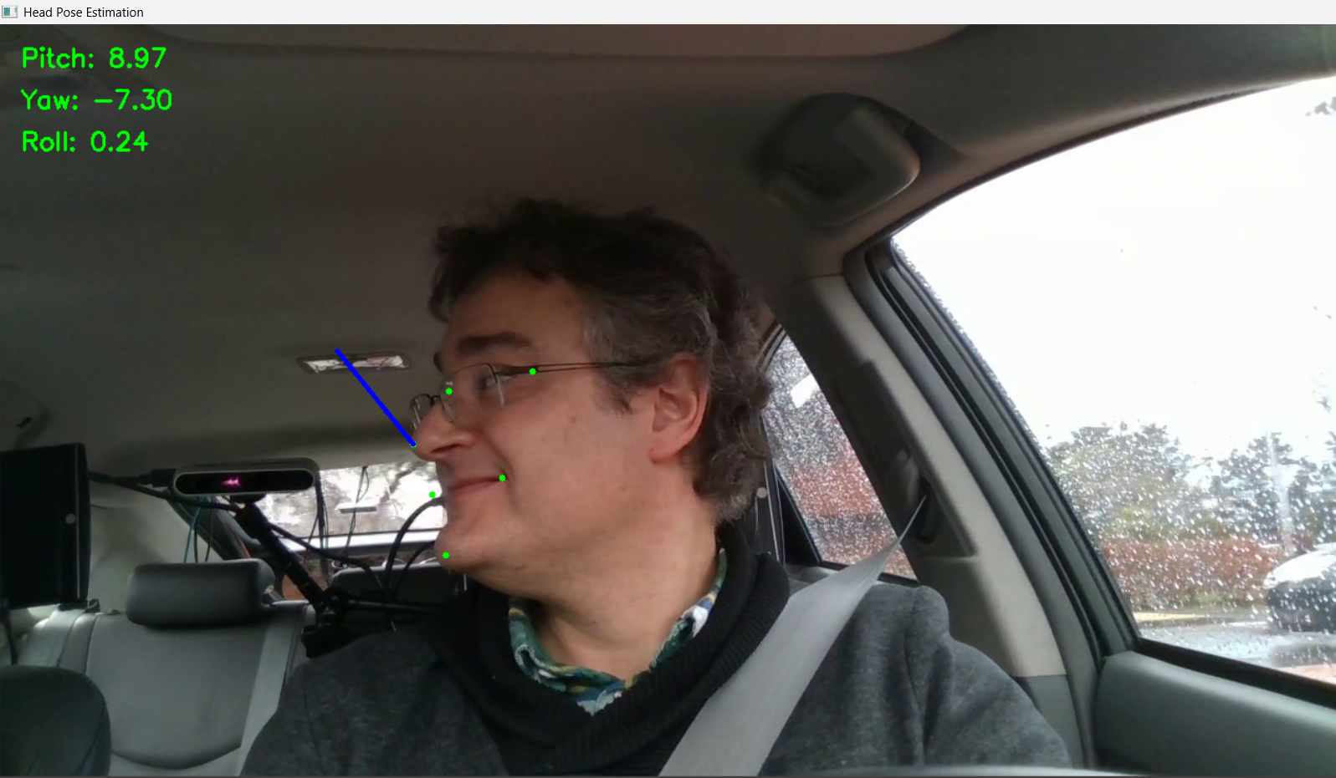

.xlsx
In this study, the CSV format was used to store features extracted from video data. During video processing, the left eye EAR value, right eye EAR value, average EAR, yaw, pitch, and roll angles calculated for each frame, along with the timestamp, were saved to a CSV file. Thus, the video data was transformed into a structured dataset that can be used by machine learning algorithms.

Problem 1:
After creating CSV files, it was observed that some numerical values were misinterpreted by spreadsheet programs during data validation. Specifically, when CSV files are opened with Microsoft Excel, numerical expressions in some cells are automatically converted to date format. For example, some cells that should contain numerical values in the dataset are displayed in date formats such as "2.Sep", "2.Aug", "Feb.43", or "1 Jan". This situation is not due to an error in the data production process; it is because Excel automatically interprets some decimal or dot-containing numbers in CSV files as date formats.
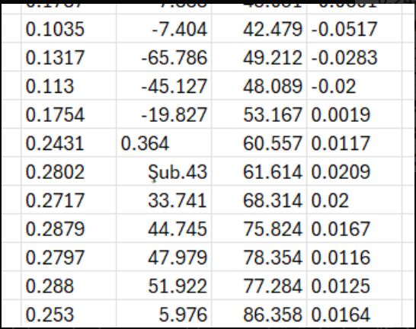
Solution:
To address the problem, the "Text to Columns" wizard in Excel was used. During this process, the data format of all columns was set to "Text." This prevented Excel from automatically converting numerical values to date format and preserved the data in the CSV file in its original numerical format.
As a result of this process, EAR values, head position angles (yaw, pitch, roll), and time information were correctly separated into columns, and the dataset was made available for analysis.
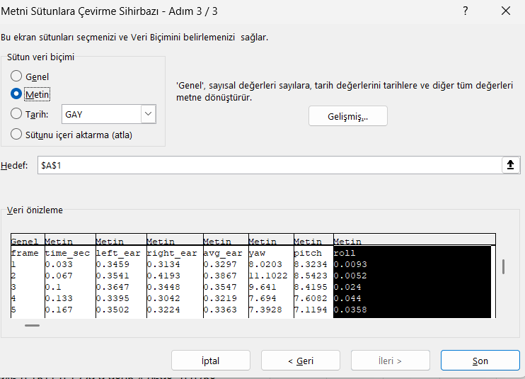

Problem 2:
After exporting features obtained from videos to CSV files in the project, it was noticed that some numerical values appeared to be incorrect when these files were examined in Excel. In particular, angular data such as yaw, pitch, and roll were displayed in Excel with magnitudes different from their actual values, initially giving the impression that there was a serious error in the pose calculation stage. For example, values seen as yaw = -23.6993, pitch = -14.8945, and roll = -8.5595 when read with pandas were displayed in Excel as -236.993, -148.945, and -85.595, respectively. Similarly, some CSV files were opened in Excel as a single column, and the table structure of the data was distorted because the column separators were not recognized correctly.

Solution:
To solve this problem, CSV files were checked with the pandas library in a Python environment instead of Excel.
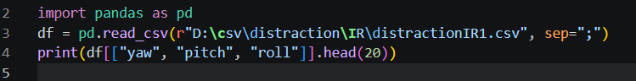
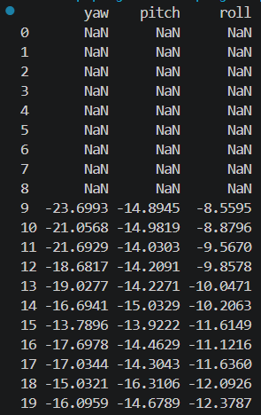
This check revealed that the values appearing as errors in Excel were actually correct within the file. Therefore, the issue stemmed not from data production but from Excel's misinterpretation of the column separator and decimal representation. Consequently, it was decided to read CSV files with pandas during analysis, converting the files to .xlsx format for visual inspection when necessary.
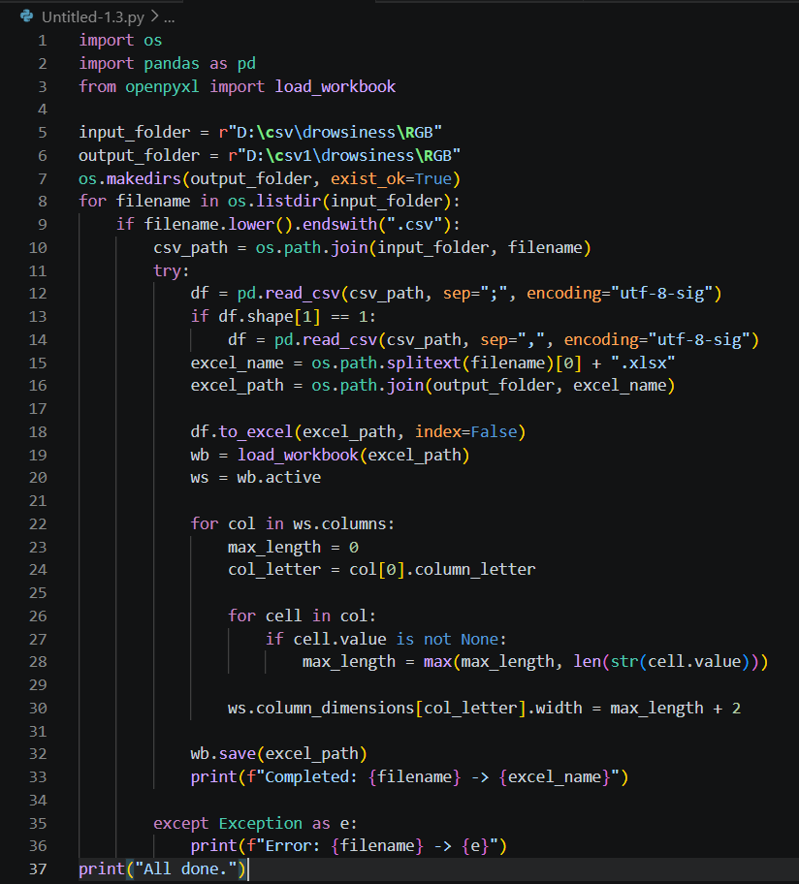

Missing Data
Missing data arises due to various reasons such as human errors, device malfunctions or software issues. Missing data can be classified into three categories:
- Missing Completely at Random (MCAR): The probability of a value being missing is independent of the variable itself or any other variables.
- Missing at Random (MAR): The probability of missingness is related to other observed variables but not the missing variable itself.
- Missing Not at Random (MNAR): The probability of missingness depends on the variable that is missing.

Data Imputation
Data Imputation is the process of handling missing values or null values in a dataset for the purpose of enhancing efficiency and accuracy in the model training process. This can be done by either replacing estimated or predicted values. Missing values occur due to various reasons, including, missing information, data entry errors, data deletion, or other inconsistencies. It is essential to handle these values to ensure unbiased predictions and data compatibility with all models.

Reasons for Occurrence of Missing Data
Some common causes are:
- Human error at time of Data entry
- Data collection issues
- Mismatched features while Dataset merging
- Data corruption or Data loss
- Inconsistent Data types
- Unanswered questionnaires

Techniques for Data Imputation
Data imputation can be performed to transform the data into a complete and consistent form using various ways. Here's an overview of some common approaches:

1. Mean, Median, Mode Imputation
Mean, Median, and Mode are used to fill null values in numerical and categorical variables. This is the most commonly used fundamental approach.
- Mean Imputation: Utilizes aggregated or average value of the entire feature or attribute to replace the missing value. Best for normally distributed numerical data. Not accurate for skewed data
- Median Imputation: Utilizes median value of the entire feature or attribute to replace the missing value. Works well for skewed or unequally distributed numerical data. More accurate and robust than mean imputation
- Mode Imputation: Replaces the missing data with the most frequently used (mode) value. Used to impute categorical features

2. Forward Fill, Backward Fill Imputation
Forward fill and Backward fill are imputation techniques based on a approach that uses nearest data point.
- Forward fill generates the last known non-null value as the imputed data using "ffill" method in pandas library while replacement. It is generally used in time series data.
- Backward fill, on the other hand, generates the next known non-null value as the imputed data using "bfill" method in pandas library while replacement. It is generally used in sequentially ordered data.

3. Regression Imputation
- This approach predicts missing values using regression based models.
- Linear regression or Non-linear regression can be used
- Relevant for numeric data
- More accurate estimation
- Can be overfitted if not handled properly

4. k-Nearest Neighbors Imputation
- This approach estimates missing data on the basis of other relevant features or variables.
- It uses distance as the parameter.
- It analyzes k nearest neighbors or data points and the multivariate relationships between them.
- This is a computationally expensive approach.
- Less efficient for large datasets.
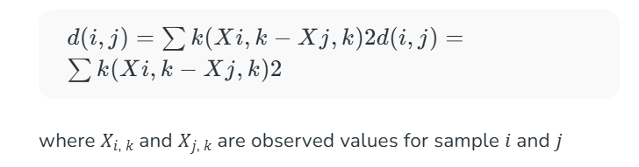

5. Multiple Imputation
This technique generates multiple predicted values corresponding to the missing values. Furthermore, these values are used in creation of several imputed datasets. Each imputed dataset is analyzed and the results are clubbed.

Advantages of Data Imputation
Some of the key advantages of Data Imputation are:
- Simple to implement and easy to understand
- Ensures consistency and completeness in data
- Enhances model performance and prediction accuracy
- Better pattern recognition and attribute relation capturing

Disadvantages of Data Imputation
Some of the key disadvantages of Data Imputation are:
- Simple imputation techniques fail to capture non-linear and complex relationships
- Variance can be reduced by Mean and Median imputation
- k-NN is computationally expensive
- Possible bias if incorrect assumptions.

Removal of Initial Invalid Data and Filling Missing Values with the Mean
Missing values at the beginning of videos often stem from frames where the system has not yet detected face or eye landmark points. Therefore, since the initial blank rows do not carry meaningful information for analysis, they have been removed from the dataset. In contrast, missing values appearing later in the dataset are generally due to brief detection errors, sudden head movements, temporary occlusions, or fluctuations in image quality. Since these types of missing data do not imply that the entire row is invalid, deleting them completely would lead to data loss. Therefore, missing numerical values in the continuing sections have been filled with the mean value of the corresponding column.

Code:
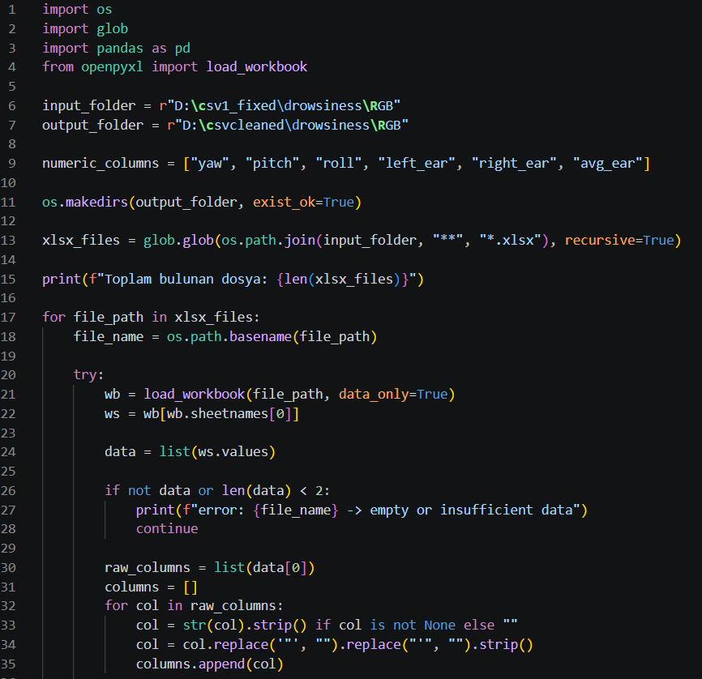
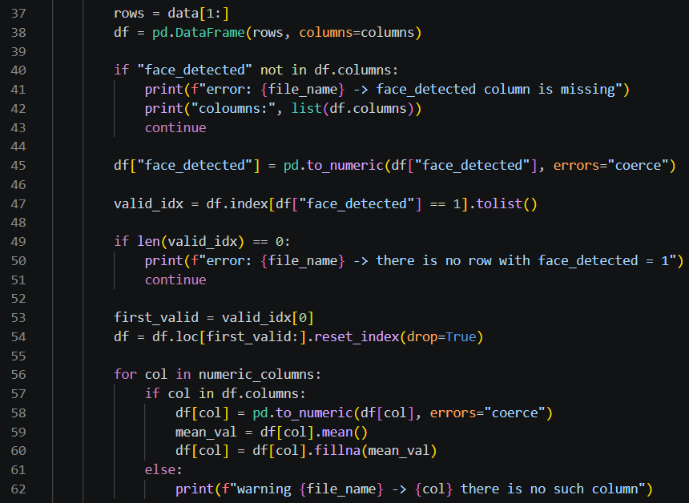
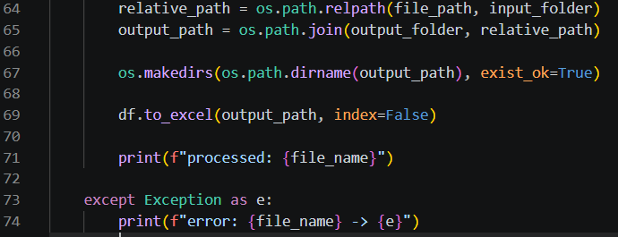

Example:
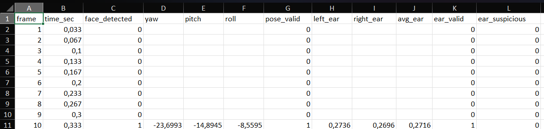
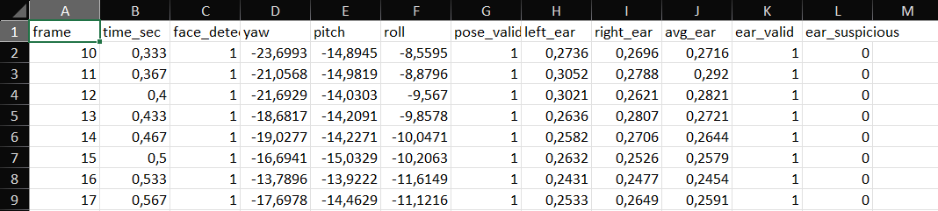

Extraction of Frames Representing Normal Gaze
In this stage, a Python script was developed to extract frames representing the driver’s normal state of attention. The script reads data files in .xlsx format and aims to select data corresponding to normal gaze based on face- and eye-based metrics obtained for each frame. During this process, columns such as frame, time_sec, yaw, pitch, roll, avg_ear, left_ear, right_ear, pose_valid, and ear_valid are utilized.
To determine normal gaze, the data is divided into fixed-length time windows. Since the videos were standardized to 30 FPS in this study, each 3-second window is defined to correspond to 90 frames. Within each window, metrics such as the average eye-opening ratio, the standard deviation of the eye-opening ratio, the average absolute horizontal head deviation, and the average absolute vertical head deviation are calculated. Additionally, the maximum head deviations within the window are also considered. By evaluating these metrics—which include low head deviation and sufficient, stable eye openness—windows where the driver is deemed to be looking at the road normally are selected. Frames within these windows classified as normal are recorded as a separate dataset, thereby creating normal-class data that can be used for model training. This approach aims to systematically distinguish between risk-free and attentive driving moments within the same video.

Code:
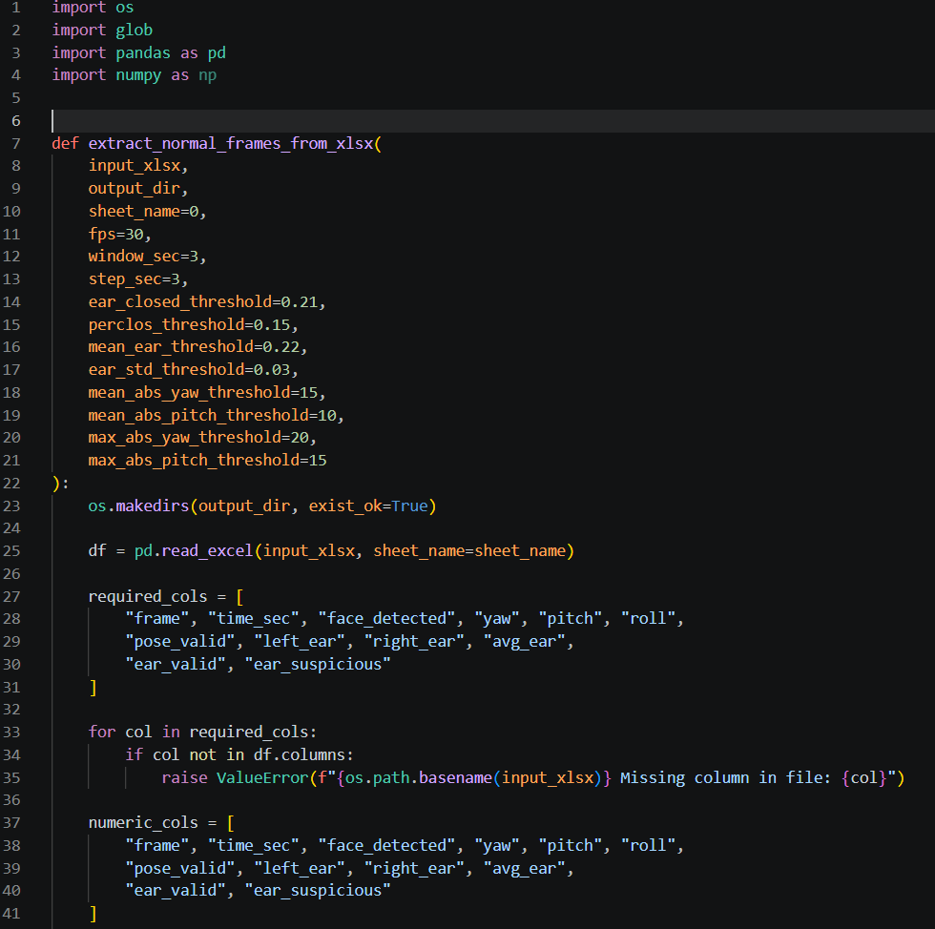
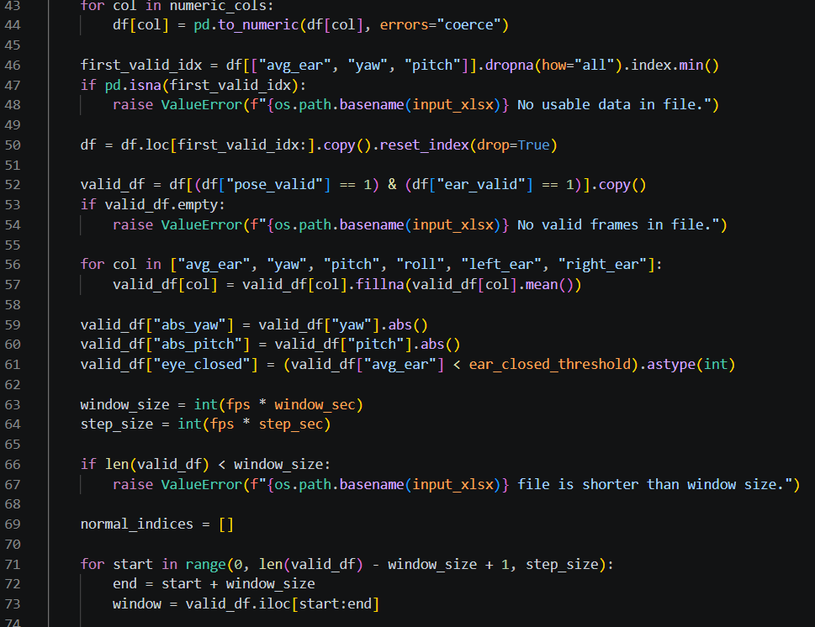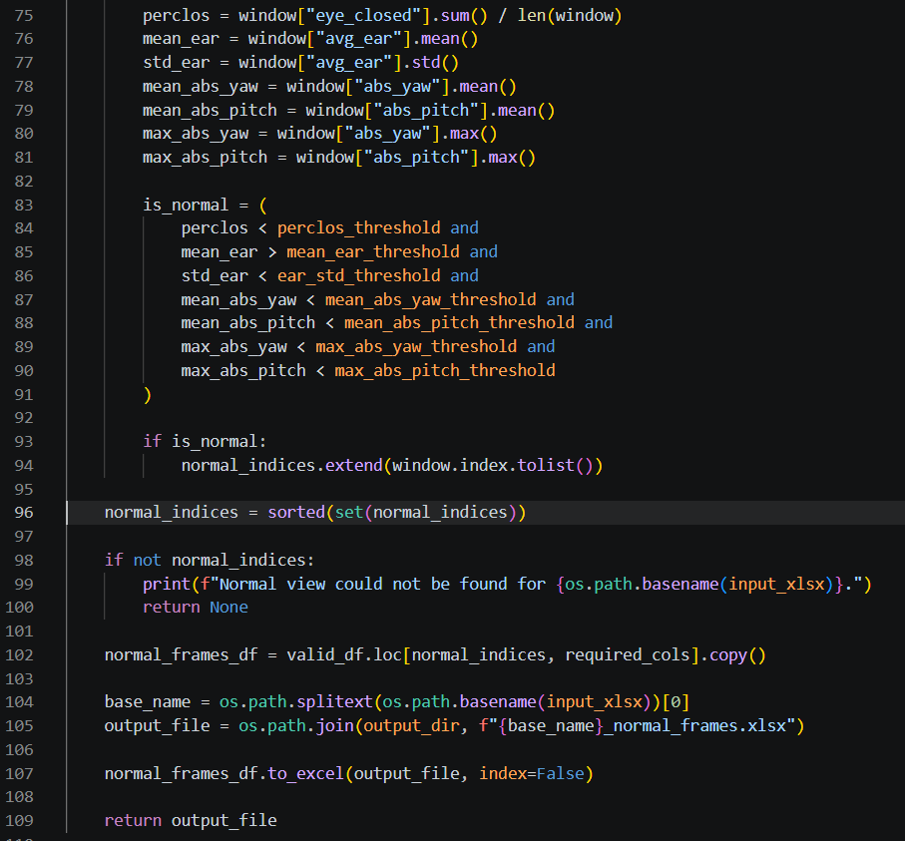
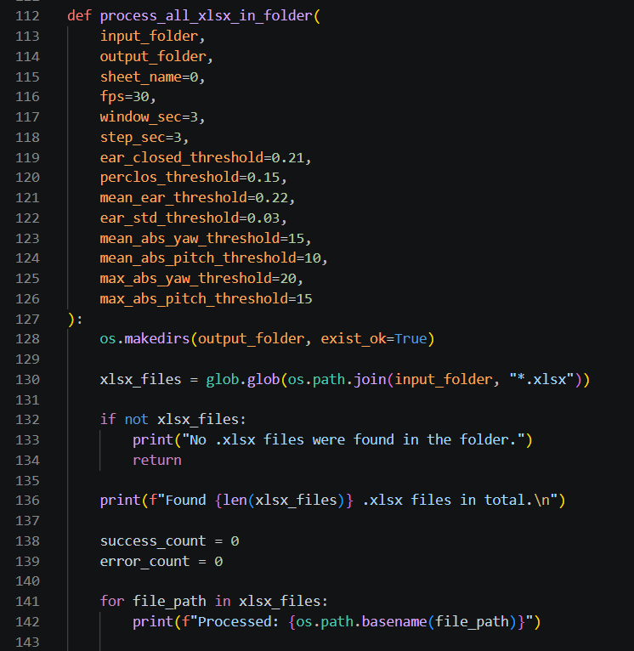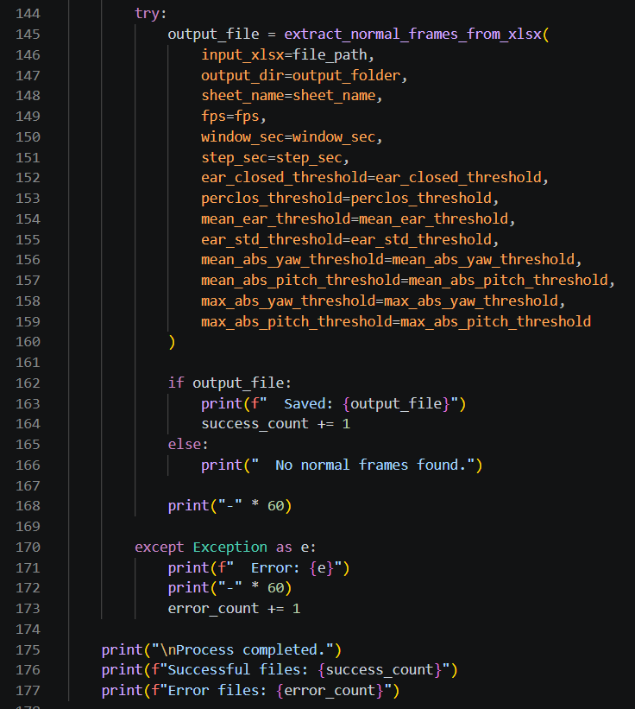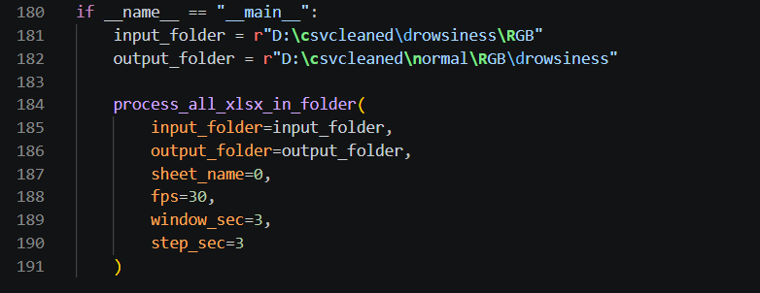

PERCLOS
PERCLOS is defined as the ratio of frames in which the eye is considered closed to the total number of valid frames within a specific time interval. The average eye aspect ratio value (avg_ear) obtained for each frame is used in the PERCLOS calculation. A threshold value is determined to decide whether the eye is open or closed, and avg_ear values below this threshold are considered as the eye being closed. Thus, the eye state is represented in binary form for each frame. The calculation process is performed on fixed-length time windows. Since the videos were standardized to 30 FPS in this study, a 3-second window corresponds to 90 frames. The number of frames in which the eye is considered closed within each window is determined, and then this number is divided by the total number of valid frames to obtain the PERCLOS value for the relevant window. The 3-second window structure reduces the effect of short-term fluctuations caused by natural blinks while allowing the driver's drowsiness tendency to be monitored with sufficient sensitivity. Shorter windows can make the measurement more volatile, while longer windows can cause delays in the detection of risky situations.
The obtained PERCLOS values are evaluated as an important feature representing the driver's drowsiness level and are saved as separate data files for use in subsequent analysis stages.

Code:
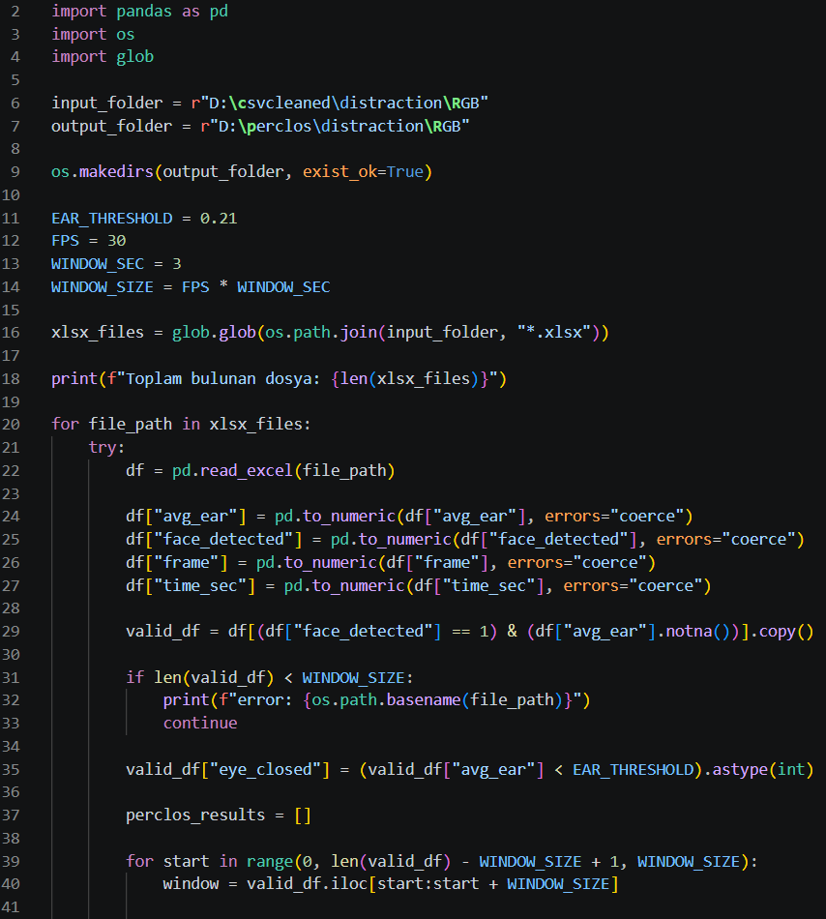
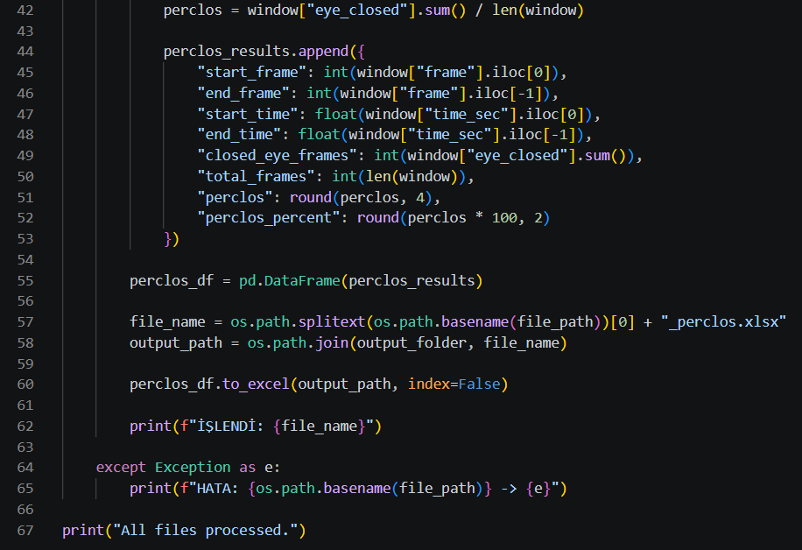

Example:
